Be Safe

Activity | Purpose | Page
1 | Calling 911 - Medical Emergency  - to learn the vocabulary associated with calling 911  - to call 911, report and describe an emergency  - to learn present continuous | 3
2 | Understand Your Municipal Civic Address  - to help those, especially living in the country, understand how to read signs and civic address signs  - to read a grid map  - to read municipal addresses | 8
3 | Calling 911 – Fire  - to learn the vocabulary of 911 for a fire  - to call 911, report and describe a fire emergency  - to listen for information | 13
4 | A Country Fire  - to call 911, report and describe a fire emergency in the country (optional)  - to improve listening skills  - to review W5 questions using the past  - to understand a local news story | 16
5 | Three Barns Destroyed  - to improve listening skills  - to listen to numbers  - to understand a local news story | 21
6 | Reporting a Car Accident  - to understand proper procedure when reporting an accident  - to use the past to report an accident | 24
7 | Safe Roads on Long Weekends  - to read for information  - to understand the ‘rules of the road’ | 29
8 | Deer on the Road  - to realize and understand safety issues with deer in Manitoba  - to improve reading comprehension skills  - to improve listening and speaking skills through guided discussion questions  - to find embedded imperatives | 33
9 | Keeping Deer Off Your Property  - to understand some of the problems with deer in Manitoba  - to improve reading comprehension skills  - to improve listening and speaking skills through sharing ideas | 37
10 | How to Dress For Winter Fun  - to review clothes and body parts  - to learn clothing vocabulary specifically for winter  - to make sentences using the conjunctions “and” and “because” | 40
11 | Understand Blizzards  - to learn about winter storms and blizzards  - to build vocabulary using a dialogue | 42
12 | Frostbite and Blizzards  - to read for understanding  - to build vocabulary  - to summarize information  - to ask questions to confirm understanding | 46
13 | Keep a Travel Kit  - to learn what to keep in vehicles for winter  - to build vocabulary | 49
14 | I’m Freezing!  - to improve pronunciation and intonation skills  - to build vocabulary using a dialogue | 55
15 | I Locked the Keys in My Car  - to learn the pronunciation of -ed endings of past verbs  - to read for content  - to exercise problem-solving skills | 59
16 | Winter Conversations  - to review winter topics  - to improve speaking and listening skills  - to share opinions and ideas | 62

1. Calling 911 - Medical Emergency

Activity 1

Purpose:
- to learn the vocabulary associated with calling 911
- to call 911, report and describe an emergency
- to learn present continuous

CLB Level:
3

Time:
30+ minutes

Materials:
- Medical Emergency Vocabulary worksheet for each learner
- Calling 911 in a Medical Emergency text for each learner
- 911 Emergency What are You Reporting? dialogue for each learner
- Medical Emergency Cards, one card for each learner

Instructions:
1. Ask learners what an emergency is. Discuss and write ideas on the board. Ask what a medical emergency is.

2. Introduce vocabulary by handing out Medical Emergency
Vocabulary worksheets. Go over pronunciation and
definitions together or in pairs. Have the learners cover
their answers. One partner reads the definition and the
other gives the vocabulary word.

3. Hand out the Calling 911 in a Medical Emergency text to each learner. Read the first two sentences together as a class making sure the learners understand the vocabulary.
Allow the learners to read the text in pairs and answer the questions together. Review the answers together as a class.

4. A: Hand out 911 Emergency – What are You Reporting? dialogue. Learners repeat the dialogue after the teacher line by line pausing for understanding and pronunciation. Pair learners and have them practice it together.

B: Explain to the learners how to form and practice the present continuous. Use Present Continuous to talk about an action that is in progress (or is happening).
- The Present Continuous is formed by adding
“-ing” to the end of a verb, along with “am”, “is”, or “are”. Use the examples below to demonstrate.
e.g. I am calling 911. He/she is calling 911.
You/they/we are calling 911.

The sentences in the exercise are common emergency situations.

C: Hand out the Medical Emergency Cards. Allow the learners to read them over and understand the emergency. Have the learners transfer the information to the dialogue and practice with a partner. Make sure they are changing the ‘yours’ to ‘my’ in the new dialogues. Learners then present the dialogue to the class.
adapted from: Caldwell Community College and Technical Institute
Medical Emergency Vocabulary

Directions: Write the words below beside its definition.

conscious ambulance fall unconscious CPR
emergency operator pulse accident

_______________ a vehicle that takes sick and injured people to the hospital.

_______________ you are awake and can think.

_______________ you put your finger on the person’s wrist or neck to see if the heart is beating.

_______________ you do this so someone’s heart beats again and so he or she breathes again.

_______________ something bad happens that you did not know would happen.

_______________ something serious happens and you must do something at this moment.

_______________ go down to the floor suddenly.

_______________ you are not awake and can not think.

_______________ a person who answers the phone and helps you

- Medical Emergency worksheet
Calling 911 in a Medical Emergency

Directions: Read the text below and answer the questions that follow.

You should call 911 only if there is an emergency. Call if the emergency is a fire, a crime you see happening, or a medical emergency. Whenever you call 911, have this information ready: your name, address, telephone number, a description of the emergency, and the location of the emergency.
If it is a medical emergency, the operator might ask questions about the person who is hurt. The 911 Operator might ask these questions: Is the person breathing? Is the person conscious? Does he or she have a pulse? It is important that you stay on the line with the operator until an ambulance and paramedics arrive. Often, the operator can tell you what to do for the person until help arrives.

Questions:

- When should you call 911? ________________________________________________________________

2. What information should you have when you call 911? ________________________________________________________________

3. What information should you have when you talk to the 911 Operator about the person who is hurt?
________________________________________________________________

________________________________________________________________

4. Why is it important to “stay on the line” until help arrives?
________________________________________________________________

- Calling 911 in a Medical Emergency worksheet
A: 911 Emergency – What are You Reporting?

911 Operator: 911 Emergency. What are you reporting?
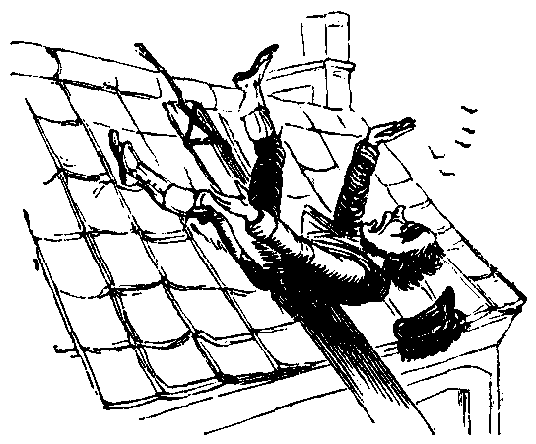
Caller: My neighbour just fell off his house.
911 Operator: Where are you?
Caller: 113 First St., Steinbach.
911 Operator: Is he conscious?
Caller: Yes.
911 Operator: Is he breathing?
Caller: Yes. I think he broke both his legs and his arms.
911 Operator: Do not move him.
Caller: OK.
911 Operator: What is your name?
Caller: John Brown.
911 Operator: And your phone number?
Caller: My cell phone is 337-1212.
911 Operator: Don’t hang up. Stay on the line until the ambulance arrives.

B: Complete each sentence below with the present continuous form of the verb
in parentheses.

1. The lifeguard (give) _______________________ CPR to the man right now.
2. Donna (call) ___________________________________ 911 for an ambulance.
3. We (wait) _________________________________for the paramedics to arrive.
4. He (lie) _______________________________________ on the floor right now.
5. My son (choke) ________________________________________ on a hotdog!
6. I think I (have) _______________________________________ a heart attack.
7. They (take) _______________________________ him to the emergency room.
8. The neighbour (run) ________________________________________ for help.
9. The firefighters (help) _________________________________with the traffic.
10. The police officer (talk) ________________________________ to the family.
11. ______________ you (dial) _________________________ the right number?

C: Use Medical Emergency Cards to role play the above dialogue.

1 911 Emergency-What are You Reporting Dialogue
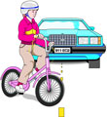  A car hit your daughter. She is breathing but unconscious. | 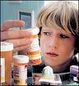  Your son ate some prescription pills. He is not breathing very well. He is conscious. His pulse is very fast.
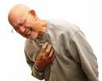  Your father is having a heart attack.  He is conscious but is having  problems breathing. | 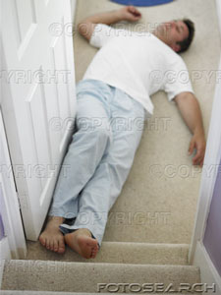  Your brother fell down the stairs and  is unconscious. He has pain in his  back and neck.
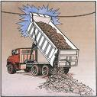  Your husband hit a wire with his truck. He’s not breathing and he’s unconscious. Someone is giving CPR  to him. | Your neighbour fell off the roof and broke his back. He’s conscious and breathing. He’s in a lot of pain.

- Medical Emergency Cards

2. Understand Your Municipal Civic Address

Activity 2

Purpose:
- to help those, especially living in the country, understand how to read signs and civic address signs
- to read a grid map
- to read municipal addresses

CLB Level:
3+

Time:
20 minutes

Materials:
- Understand Road Signs and Civic Address Signs text for each learner
- How Your Civic Address Works text for each learner
- Map of South East Manitoba for each pair of learners
- Answer Key Map OHT

Instructions:

1. Use with a 911 lesson.

2. Have the learners who live in the country tell the class how to get to their homes. Take note whether they are using landmarks or not in their explanations.

3. Ask learners if they have signs on their driveways. Write their address on the board or make one up such as 32150 and ask learners for the meaning of the numbers. 32150 is a civic address. 33N is a road sign. NOTE: the last three numbers do not go higher than 160.

4. Pronunciation: Numbers in civic addresses are said individually: three, two, four, five, zero Road thirty-three North.

5. Hand out Understand Road Signs and Civic Address Signs texts to the learners. Read the title together. Have learners read the text after you or read in pairs.

6. Learners answer questions on their own and then check with a partner.

7. Hand out How Your Civic Address Works text and the map. Walk through this section with the learners using the maps to follow along.
Two things to note:
a) If the road has an E (East), it actually runs North/South and vice-versa.
b) Everything is in miles except the last three numbers, which are metric. As with other things (buying building supplies) we speak in inches and feet but on the computer it comes out metric.

8. With a partner have learners find their civic addresses and the civic addresses in the bottom exercise, marking them on the map. Listen for pronunciation. Learners then quiz each other on the addresses and/or can make new ones.

Understand Road Signs and Civic Address Signs

Do you know your address? It is important to memorize it and remember it.
911 emergency service providers (police, fire and ambulance) want to get to your house quickly when there is an emergency. Manitoba Hydro and Manitoba Telephone System also need to know your address to give you better and faster service.
If you live in a city or town you have a house number and a street name as part of your address e.g. 76 Hanover Street, Steinbach.
In the country, you have a road sign at the end of your road.
30N
This has a number and a letter, e.g. 30N.
and, you have a number sign at the end of your driveway,
29036
e.g. 29036. This is your civic address sign.
It is like a house number. Your complete civic address might be
29036 Road 30N.
This is different from your box number. Your box number is for mail and your civic address is for location.

Answer the questions below.

1. Why is it important to memorize and remember your address?
__________________________________________________________________

2. Who needs to know your address?
__________________________________________________________________

3. Do you have a street address or a civic address?
__________________________________________________________________

4. What is your street address or civic address?
__________________________________________________________________

5. What is your mailing address?
__________________________________________________________________

- Understand Road Signs and Civic Address Signs
How the Civic Address Works

An explanation of how the road signs and civic addresses work.
Example A: 29036 Road 30N. Use the map to help you.

1. 30 N – is an east/west road that you live on and it is 30 miles north of the
United States border.
2. 29 in the number 29036 – is a north/south road and it is 29 miles east of the
prime meridian. The prime meridian runs just west of Headingley, MB.
3. 036 in the number 29036 – is how many kilometres you are past the 29
north/south mile road going toward the 30 north/south mile road. You
are .36kilometres past the 29 mile north/south road.

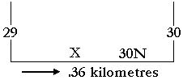

Where is this address on the map? Put an “X” on the place on the map.
Example B: 22135 Road 25E
1. 25 E – is a north/south road that you live on and it is 25 miles east of the prime
meridian.
2. 22 in the number 22135 – is an east/west road and it is 22 miles north of the
United States border.
3. 135 in the number 22135 – is how many kilometres you are past the 22 east/west mile road going toward the 23 east/west mile road. You are 1.35 kilometres past the 22 east/west mile road.
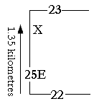

Where is this address on the map? Put a “0” on the place on the map.

3. Do you live in the country? Find your civic address on this map. Place a check (✓) on the place on the map.

Find these Municipal Civic Addresses:
05125 Road 25E Put a ① there. | 33158 Road 40E Put a ④ there.
22075 Road 30E Put a ② there. | 30042 Road 30N Put a ⑤ there.
30100 Road 27N Put a ③ there. | 28057 Road 16E Put a ⑥ there.

- How the Civic Address Works

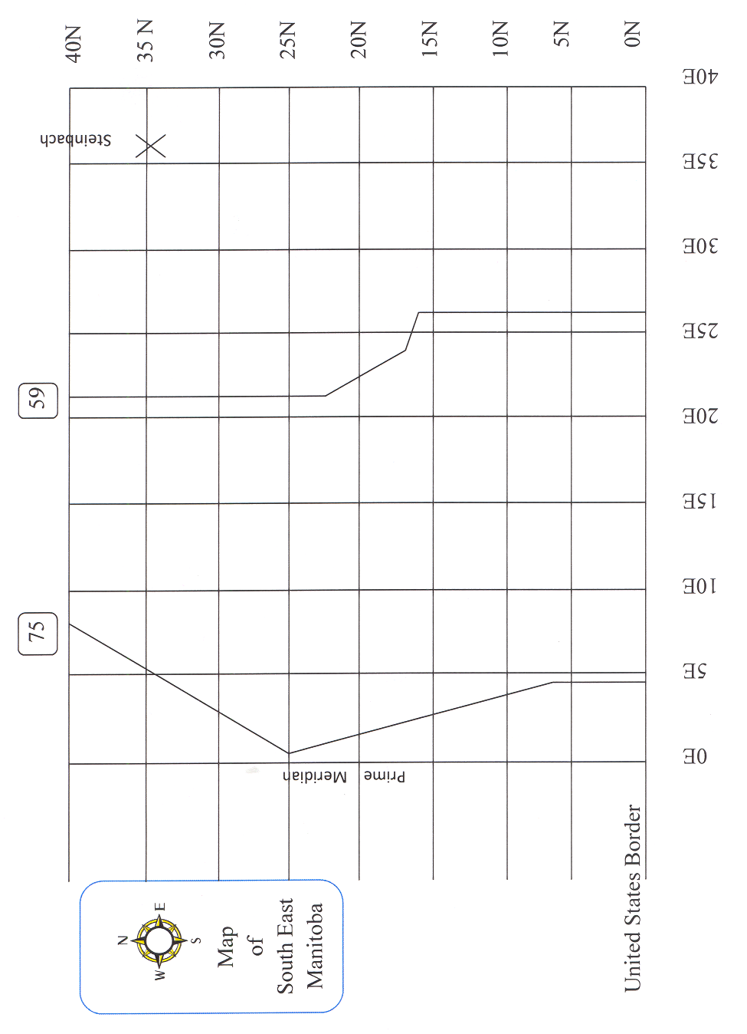

Map of South East Manitoba

- Maps of South East Manitoba
Answer Key:
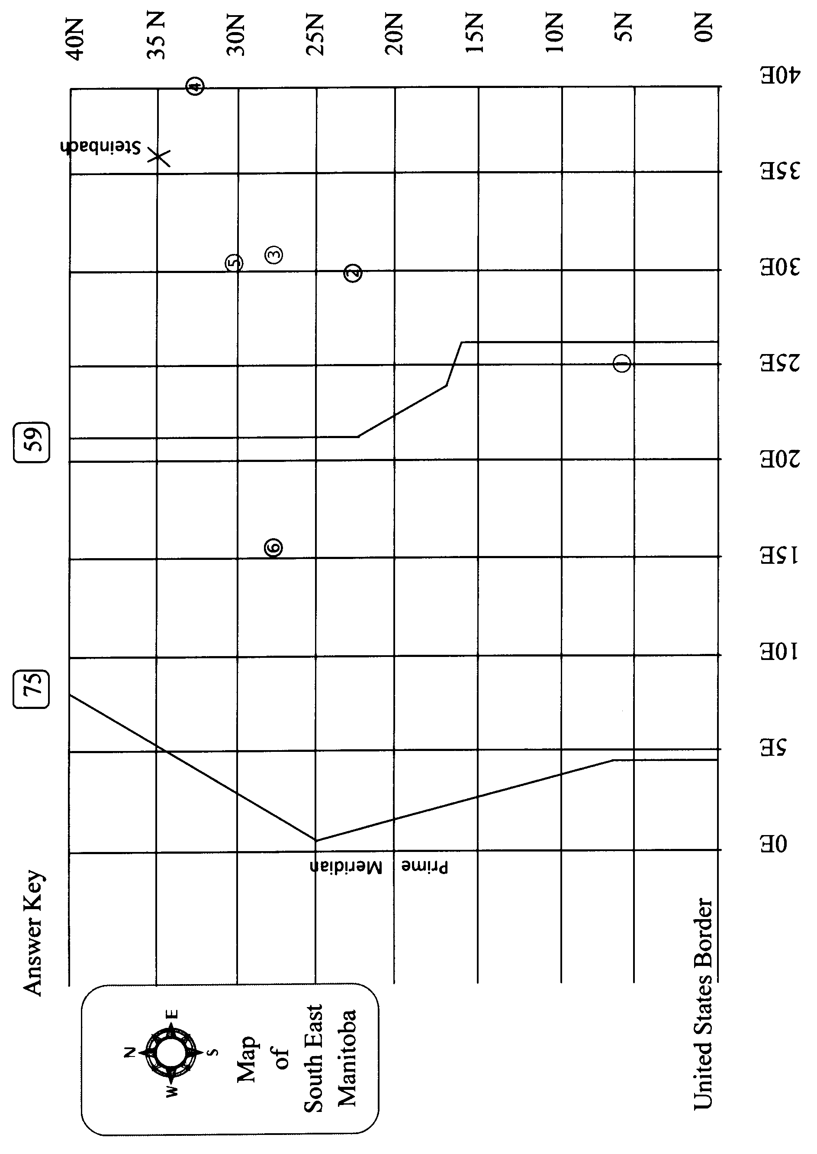

4

★

2
3
5

1

6

- Maps of South East Manitoba Answer Key
3. 911 - Fire

Activity 3

Purpose:
- to learn the vocabulary of 911 for a fire
- to call 911, report and describe a fire emergency
- to listen for information

CLB Level:
3/3+

Time:
20 minutes

Materials:
- Help! Fire! Dialogue for each learner
- Which One Is Right worksheet for each learner

Instructions:

1. Tell the class this lesson is for a fire emergency. Have a class discussion on the word emergency. What is an emergency? Discuss the numbers 911. What is the emergency number in the learners’ countries?

2. Hand out the Help! Fire! Dialogues to the learners for them to fill in. If spelling is a problem, write the answers in random order on the board for them to use to fill in the information. Read the dialogue slowly. Repeat it several times and pause as they fill in the information.

3. Check answers together, discuss the dialogue, answering any questions they may have. Go over any new vocabulary.

4. Learners repeat dialogue after teacher line by line and then go over dialogue together in pairs.

5. Hand out the Which One Is Right worksheet to each learner. Have the learners fold the sheet in half lengthwise. Divide the class into pairs to complete the activity. Partners switch roles to give each learner the opportunity to listen.

Dialogue to be dictated:
911 Operator: Do you require police, fire, or ambulance?
Caller: Fire. There’s a fire in my house!
911 Operator: What is the address?
Caller: 76 Home Street, Steinbach.
911 Operator: Where is the fire?
Caller: In my daughter’s bedroom
911 Operator: What happened?
Caller: A candle fell off the dresser.
911 Operator: Where are you calling from?
Caller: From my kitchen.
911 Operator: Is anyone with you?
Caller: No, everyone is outside.
911 Operator: Leave the house immediately. A fire truck is on the way.
Caller: Okay, Bye.
911 Operator: Bye.


Listen to the dialogue and fill in the blanks.

Help! Fire!

911 Operator: Do you require police, fire, or ambulance?
Caller: Fire. There’s a _________________ in my house!
911 Operator: _______________________ is the address?
Caller: 76 Home Street, Steinbach.
911 Operator: ______________________ is the fire?
Caller: In ______________ daughter’s bedroom.
911 Operator: What happened?
Caller: A candle _________________ off the dresser.
911 Operator: ______________________ are you calling from?
Caller: ____________________ my kitchen.
911 Operator: Is anyone ______________________ you?
Caller: No, ____________________________ is outside.
911 Operator: Leave the _____________________ immediately. A fire ______________ is on the way.
Caller: Okay, Bye.
911 Operator: Bye.

3 Help! Fire! Dialogue
Which One Is Right?
Fold the page in half, lengthwise

The caller’s part of the dialogue is not in the right order. The Caller listens to the 911 Operator and finds the correct response, numbering the statements from 1-6.
911 Operator_
1. Do you require police, fire
or ambulance?
2. What is the address?
3. Do your neighbours know
that there is a fire?
4. Is everyone out of the
neighbour’s house?
5. Can we have your phone
number?
6. Stay away from the fire. The
fire trucks are one the way.
Caller____ __
____ Yes, I phoned them.
____ OK. Thank you.
____ 325 North Drive, Steinbach.
____Yes, it’s 364-4552.
____ Fire. There’s a fire in my
neighbour’s garage.
____ Yes, they are at my house.
1.

FOLD

SWITCH ROLES: The other person SWITCH ROLES: The other person
is now the 911 Operator. is now the Caller
911 Operator_
1. Do you require police, fire
or ambulance?
2. What is the address?
3. Is there anyone near the fire?
4. Tell them to clear the area.
5. Can we have your phone
number?
6. The fire trucks are one the
way.
Caller____ __
____ Yes, it’s 398-3451.
____ I’ll tell them.
____ Fire. There’s a fire in the
bush.
____Yes, some men are trying to
put out the fire.
____ Thank you.
____ 24105 Road 39E.
2

3 Which One Is Right worksheet
4. A Country Fire

Activity 4

Purpose:
- to call 911, report and describe a fire emergency in the country (optional)
- to improve listening skills
- to review W5 questions using the past
- to understand a local news story

CLB Level:
3/3+

Time:
20 minutes

Materials:
- That Was Too Close worksheet for each learner
- What Did You Remember-Making Questions worksheet OR
- What Did You Remember-Asking Questions worksheet
(each page makes 2 copies)

Instructions:

1. Hand out That Was Too Close worksheet. (This is a good activity if you have learners who live in the country area.) Go over the verbs together as a class and fill in the past verbs at the top of the worksheet.

2. Have learners complete the sentences in the text and then read the text together. (Optional: Learners can use this as a follow-up to the second dialogue in the Which One is Right worksheet and use this story to make up a short ‘Calling 911’ dialogue.)

3. Briefly go over the Who, What, When, Where, Why, Which, How many, How much definitions with the learners. Who – people, What – information, When –time, Where – place, Why – reason (uses because), which – choice (east, west or north), how many (countables), how much (non-countables). Explain to the learners that when we use these question words with verbs we use ‘do’ in the present and ‘did’ in the past. e.g. Where do you make a fire? vs. Where did you make a fire?

4. Hand out What Did You Remember? – Making Questions worksheet to the higher level learners. Have them put the words into the correct order to make questions. Divide the learners into pairs and have them ask each other the questions.

5. Hand out What Did You Remember? – Asking Questions worksheet to the learners if not using the worksheet in instruction #4. Divide the learners into pairs and have them ask each other the questions.

That Was Too Close

Write the past tense verb for each word.

1. has _____________ 6. is _____________
2. save _____________ 7. spread _____________
3. decide _____________ 8. pour _____________
4. take _____________ 9. get _____________
5. call _____________ 10. come _____________

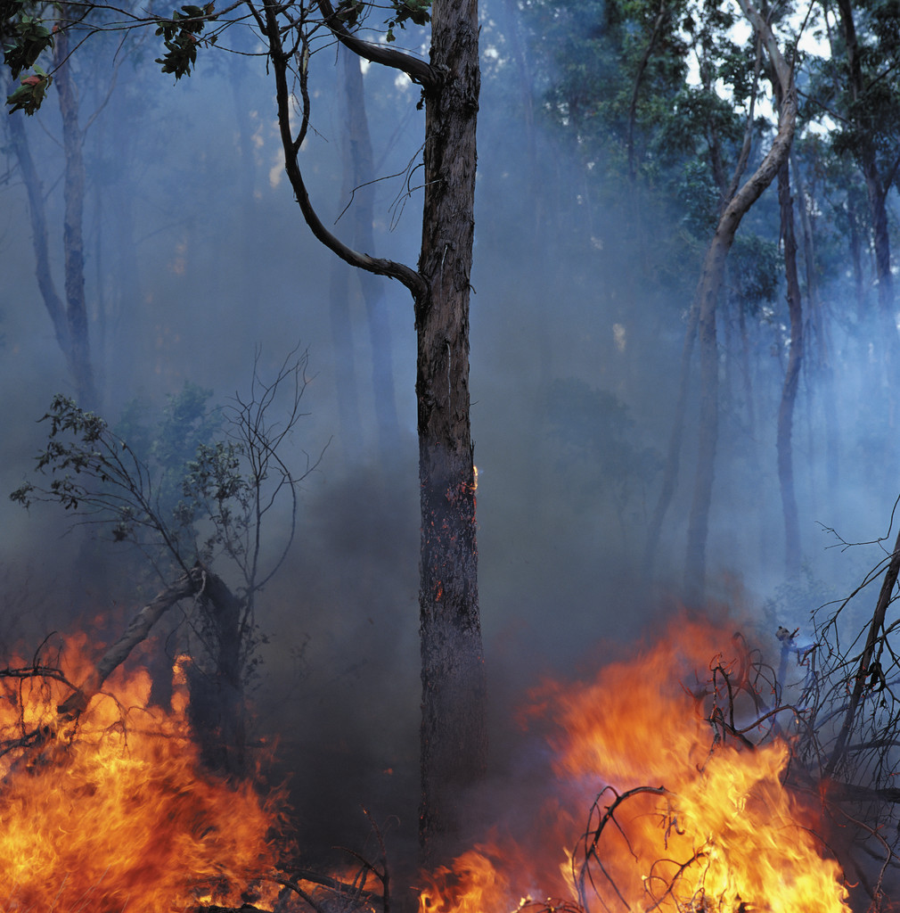
A farmer __________ 911 when the fire on his property ________
(call) (get)
out of control. Last Friday evening, a farmer ________________ to
(decide)
burn some of the dead wood at the back of his property. The wind

_________ stronger in the later evening and the fire ____________
(get) (spread)
west towards his chicken barns. He ___________ two barns with 15,000 chickens
(has)
in each barn. Firefighters ___________ from three different communities to help.
(come)
It ________________ them four hours to put the fire out. The firefighters
(take)
__________________ water on to the barns and ________________them. The
(pour) (save)
farmer ____________ very thankful but he _____________ to pay a $260.00 fine
(is) (have)

because he _____________ careful enough.
(isn’t)
4 That Was Too Close Worksheet
What Did You Remember? – Making Questions

Put the words into the right order to make questions. With a partner take turns reading and answering the questions. Remember to use a capital letter for the first word and a question mark at the end of each sentence.

1. farmer / did / 911 / call / What / the / time
What time did the farmer call 911? __________________________
2. call / did / the / 911 / farmer / Why
_____________________________________________________________
3. did / What / burn / farmer / the
_____________________________________________________________
4. the / spread / fire / Why / did
_____________________________________________________________
5. Which / the / did / direction / spread / fire
_____________________________________________________________
6. did / chickens / How / the / have / many / farmer
_____________________________________________________________
7 from / come / firefighters / the / did / Where
_____________________________________________________________
8. How many / did it / hours / take / firefighters / put / the fire / the / out / to
______________________________________________________________
9. What / do / the / firefighters / did
______________________________________________________________
10. feel / did / farmer / How / the
______________________________________________________________
11. farmer / the / pay / have / How / did / to / much
______________________________________________________________

4 What Did You Remember? – Making Questions worksheet

Answer Sheet: What Did You Remember? – Making Questions

Put the words into the right order to make questions. With a partner take turns reading and answering the questions. Remember to use capital letters for the first words and question marks.

1. farmer / did / 911 / call / what / the / time
What time did the farmer call 911?
2. call / did / the / 911 / farmer / why
Why did the farmer call 911?
3. did / what / burn / farmer / the
What did the farmer burn?
4. the / spread / fire / why / did
Why did the fire spread?
5. which / the / did / direction / spread / fire
Which direction did the fire spread?
6. did / chickens / how / the / have / many / farmer
How many chickens did the farmer have?
7 from / come / firefighters / the / did / where
Where did the firefighters come from?
8. how many / did / hours / take / the firefighters / it / put / fire / the / out / to
How many hours did it take the firefighters to put the fire out?
9. what / do / the / firefighters / did
What did the firefighters do?
10. feel / did / farmer / how / the
How did the farmer feel?
11. farmer / the / pay / have / how / did / to / much
How much did the farmer have to pay?
4 What Did You Remember? – Making Questions worksheet
Answer Key
What Did You Remember?—Asking Questions
Partner A: Ask Partner B questions 1-6.
1. What time did the farmer call 911?
2. Why did the farmer call 911?
3. What did the farmer burn?
4. Why did the fire spread?
5. Which direction did the fire spread?
6. How many barns did the farmer have?

Partner B: Ask Partner A questions 7-12.

7. How many chickens did the farmer have?
8. Where did the firefighters come from?
9. How many hours did it take the firefighters to put the fire out?
10. What did the firefighters do?
11. How did the farmer feel?
12. How much did the farmer have to pay?


What Did You Remember?—Asking Questions
Partner A: Ask Partner B questions 1-6.
1. What time did the farmer call 911?
2. Why did the farmer call 911?
3. What did the farmer burn?
4. Why did the fire spread?
5. Which direction did the fire spread?
6. How many barns did the farmer have?

Partner B: Ask Partner A questions 7-12.

7. How many chickens did the farmer have?
8. Where did the firefighters come from?
9. How many hours did it take the firefighters to put the fire out?
10. What did the firefighters do?
11. How did the farmer feel?
12. How much did the farmer have to pay?

4 What Did You Remember? – Asking Questions worksheet
5. Three Barns Destroyed

Activity 5

Purpose:
- to improve listening skills
- to listen to numbers
- to understand a local news story

CLB Level:
3/3+

Time:
20 minutes

Materials:
- Three Barns A and B worksheets for each pair of learners

Instructions:

1. Explain that this is a listening activity involving numbers.
2 Count to 20,000 by thousands together as a class (1,000, 2,000, etc.) and then by 10,000 to 100,000. Write random numbers on the board (1,200, 10,300, 15,600, etc.) and have learners say them.
3. Divide learners into pairs and hand out Three Barns A worksheet and Three Barns B worksheet. Learner A says his/her numbers to learner B and learner B writes down the numbers heard. Learner B then says his/her numbers to learner A and learner A writes down the numbers heard.
Learners check that the numbers have been written correctly.
4. Explain that in the reading some barns were burned. There were hogs and chickens in the barns. The firefighters worked hard to save the barns. Fire crews are a group of firefighters.
5. Read text slowly and allow learners to fill in the numbers they hear. Read it several times for the learners to finish.
6. Have the learners finish the remaining questions through discussion.
7. This could be used as a follow-up lesson for calling 911, Activity 3.

Newspaper article to be read to the learners:

Three Barns Destroyed By Landmark
Based on the story written by AM 1250/Mix 96 FM News, Saturday, 30
September 2006

Damage is estimated at $5 million after an early morning fire northwest of Landmark. Tache fire crews responded to the barn fire around 4:30 a.m. at Rainbow Farms. By the time fire crews arrived three barns were engulfed in flames. They saved one hog barn with 2200 hogs and one chicken barn. But 5500 hogs died in the other two barns. Crews spent all morning on the scene. A total of seven fire departments responded to the call.

A: Thousand – Number Pronunciation

Say these numbers to your partner. | Write down the numbers you hear.
3,200
4,416
15,220
6,024
60,115
13,150
75,430
120,600
83,640
132,753

Listen to the newspaper story and fill in the blanks with numbers.

___________ BARNS DESTROYED BY LANDMARK

1. Damage is estimated at __________________ dollars.
2. Fire crews responded to the fire around ____________ a.m. at Rainbow Farms.
3. By the time they arrived, __________________ barns were engulfed in flames.
4. They saved _________ hog barn with ___________ hogs and _______ chicken
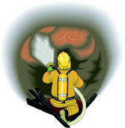
barn.
5. But ________________ hogs died in the other two barns.
6. Crews spent ____________ morning on the scene.
7. A total of __________ fire departments responded to the call.

Questions:

1. Where did this happen? __________________________________________
2. What was the name of the Farm? ____________________________________
3. How long did the crews work there? __________________________________

5 Three Barns A worksheet
B: Thousand – Number Pronunciation

Say these numbers to your partner. | Write down the numbers you hear.
6,800
17,540
21,100
9,024
50,515
18,150
42,340
110,700
36,480
230,860

Listen to the newspaper story and fill in the blanks with numbers.

___________ BARNS DESTROYED BY LANDMARK

1. Damage is estimated at __________________ dollars.
2. Fire crews responded to the fire around ____________ a.m. at Rainbow Farms.
3. By the time they arrived, __________________ barns were engulfed in flames.
4. They saved _________ hog barn with ___________ hogs and _______ chicken
barn.
5. But ________________ hogs died in the other two barns.
6. Crews spent ____________ morning on the scene.
7. A total of __________ fire departments responded to the call.

Questions:

1. Where did this happen? __________________________________________
2. What was the name of the farm? ____________________________________
3. How long did the crews work there? __________________________________

5 Three Barns B worksheet
6. Reporting a Car Accident

Activity 6

Purpose:
- to understand proper procedure when reporting an accident
- to use the past to report an accident

CLB Level:
3/4

Time:
40 minutes

Materials:
- Reporting a Car Accident worksheet for each learner
- Accident Details worksheet for each learner
- Car Accident worksheet for each learner
- Car Parts worksheet cut in half for each learner
- Car model or toy car

Instructions:

1. Lead a discussion about what learners have to do in their country if their vehicles are involved in an accident. Ask learners what they know about reporting accidents in Canada.

2. Hand out the Reporting a Car Accident worksheet. Have the learners circle any words that they are unfamiliar with.

3. Have the class give the words while they are written on the board. Work out the definitions together.

4. Have the learners fill in the True and False questions.

5. Hand out the Accident Details worksheet and go over the information that needs to be collected from the Hit and Run Reported newspaper article. Have the learners read through the article and fill in the Accident Details worksheet.

6. Go over answers, explaining and discussing any questions or comments brought out.

7. Hand out the Car Accident worksheet and use the pictures as guided dialogue practice. Go over the past verbs they will need to be used for this task. This gives practice with common scenarios of common road accidents.

8. Hand out the Car Parts worksheet and have learners work in pair labelling the different parts of the car. As a class go over the vocabulary and add extras such as trunk, wheel, etc. Have learners identify parts of the car that would have been damaged in the Car Accident worksheet.
Use a car model or toy car to help identify parts.

Reporting a Car Accident
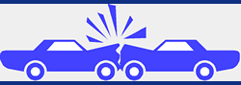

If you have a vehicle accident, there are several things you must do.

1. You must always stop. NEVER drive or walk away.
2. You must report the accident to the police if someone was hurt, or if there was damage over $1,000 to the vehicles or to someone’s property. You have 21 days to report the accident.
3. Write down the information of the other driver’s license and registration.
4. Write down the names and addresses of passengers.
5. Write down the names and addresses of witnesses.
6. Write down the time and the location of the accident.
7. Write down the road conditions and how the weather was.
8. Report all accidents to MPI. The accident might be a minor accident or it might not be your fault but you should report it.
9. After MPI makes an appointment with you and inspects your vehicle, take it to an auto body mechanic to get it repaired.

Read each sentence. If it is true, write T. If it is false, write F.

_____ 1. Always stop if you are in an accident.
_____ 2. Write down all the information at home.
_____ 3. You should report all accidents to the insurance company.
_____ 4. Write down the names and addresses of all the people who were in the accident.
_____ 5. If no one is hurt but your car has $8,000 damage, you don’t have to report the accident to the police.
_____ 6. An auto body mechanic makes the inspection on your vehicle.

6 Reporting a Car Accident worksheet
Accident Details
Time of accident: ____________________ a.m. ____________________ p.m.
Date of accident: day ____________ month _____________ year __________
Where it happened: Street: __________________ City: ___________________
Other: ______________________________________________
How did the accident happen: _________________________________________
__________________________________________________________________
__________________________________________________________________
Description of your vehicle’s damage: __________________________________
__________________________________________________________________
__________________________________________________________________
Description of the other vehicle’s damage: _______________________________
__________________________________________________________________
__________________________________________________________________

SKETCH OF ACCIDENT SCENE WHO SAW THE ACCIDENT
Witness #1

Name: ________________________
Address: ______________________
Phone: Work: _________________
Home: ________________

Hit and Run Reported
T
HE Steinbach RCMP are looking for the driver of a vehicle responsible for a minor hit- and-run accident on Wednesday, March 12.
Constable Rob Caron said the accident happened in the visitor parking lot of the Steinbach Regional Secondary School on McKenzie Road, sometime between 4 and 4:30 p.m.
The owner of a light-coloured Mazda mini-van was in the school when a black pickup truck struck the back end while it was parked.
Caron said that after the collision, the driver of the truck got out of his truck, looked at the two vehicles and then left. The rear brake light of the mini-van was broken. The bumper and the left rear fender were dented.
Students who saw the accident did not have any other information. Anyone with more information on this accident is asked to call the Steinbach RCMP detachment at 326-1234 or Crime Stoppers at 1-800-782-8477. (The Carillon, 2000) 6 Accident Details worksheet
A Car Accident

Dialogue:

Police: What happened?
Mr. Bell: He went through the red light and hit me. (She)
I tried to stop but I couldn’t.
Police: Was anyone hurt?
Mr. Bell: No, just a little shook up.
Police: Can I have your driver’s license and registration?

Practice this dialogue with the accidents below. Remember to use the past tense.
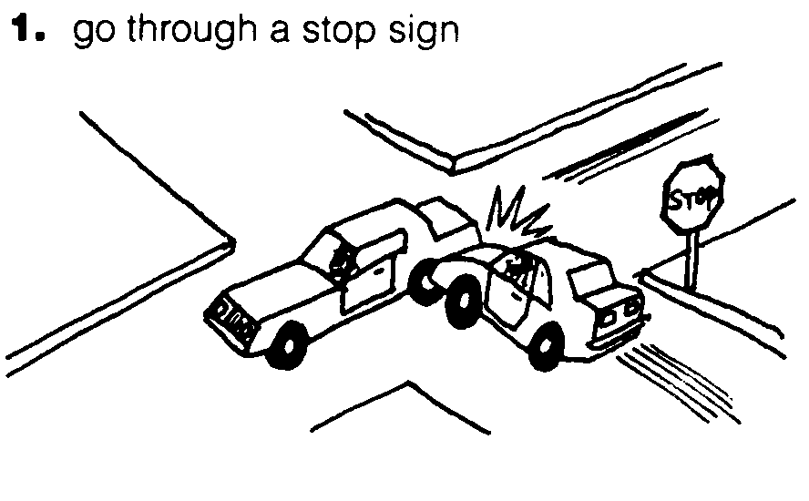 | 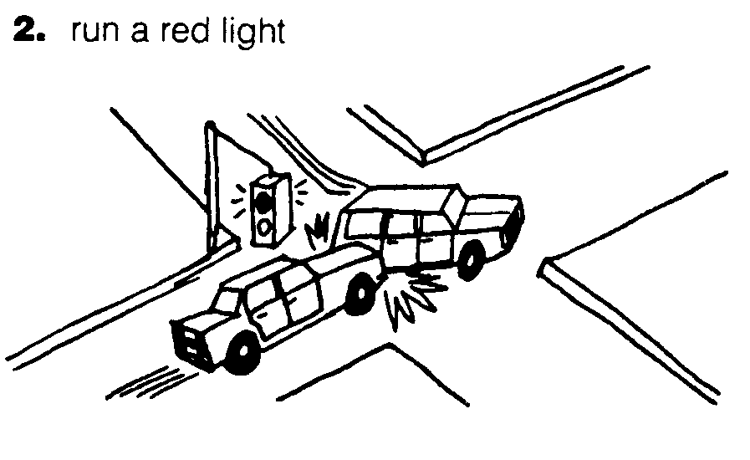
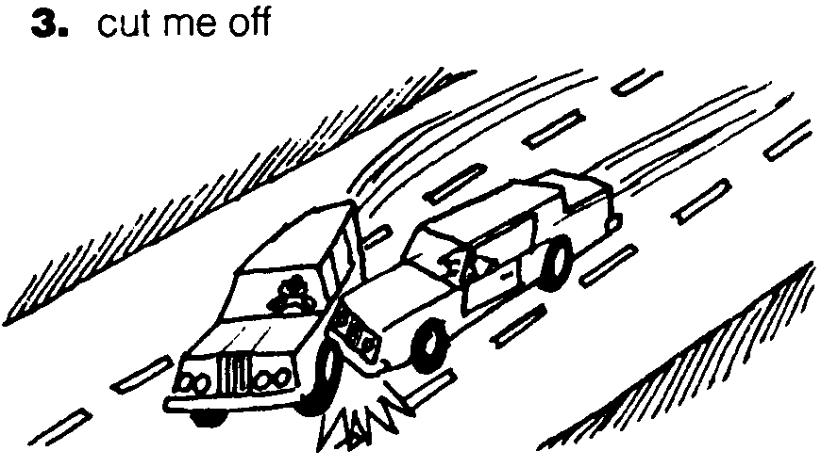 | 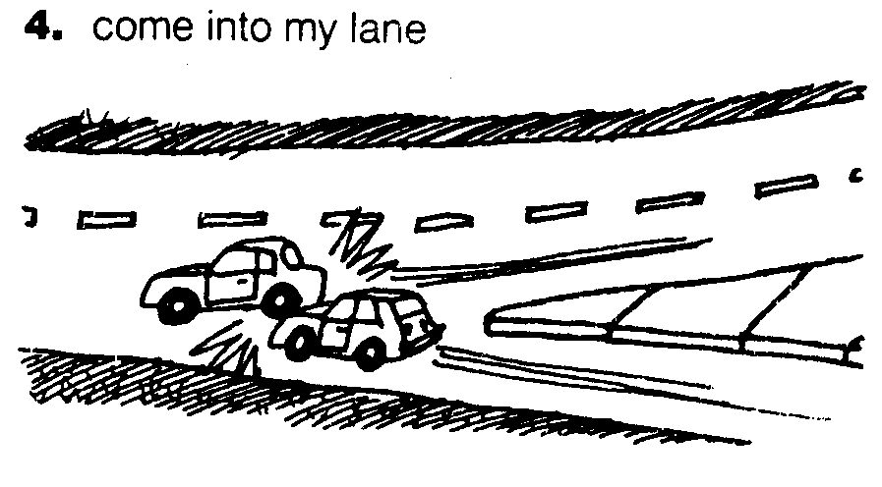
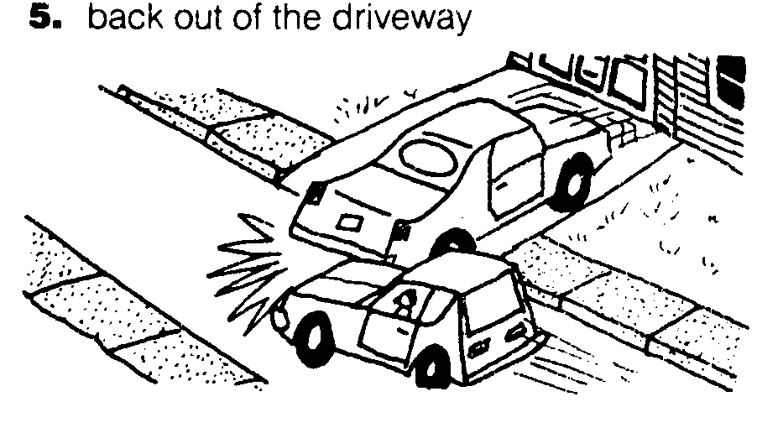 | 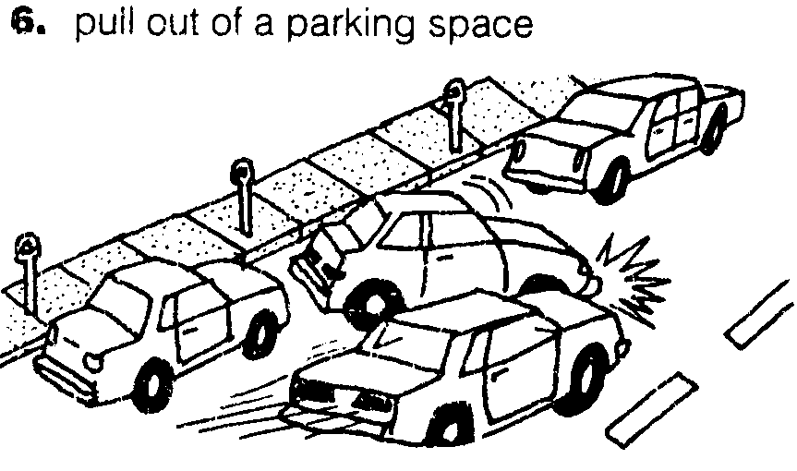
6 A Car Accident Dialogue
Car Parts
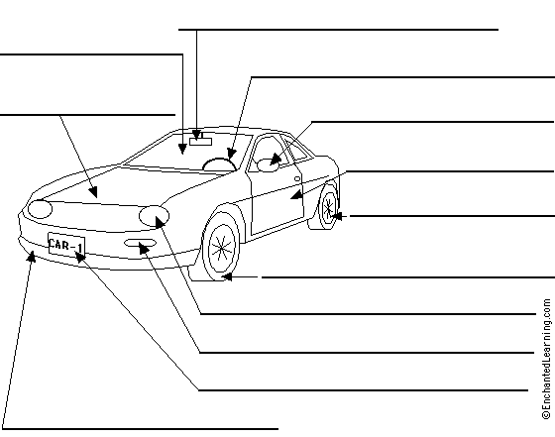
Label the different car parts
1. bumper
2. license plate
3. rear view mirror
4. tire
5. door
6. steering wheel
7. side mirror
8. rear fender
9. headlight
10. turn signal
11. front fender
12. hood
13. hubcap
14, windshield

6 Car Parts worksheet

Car Parts
Label the different car parts
1. bumper
2. license plate
3. rear view mirror
4. tire
5. door
6. steering wheel
7. side mirror
8. rear fender
9. headlight
10. turn signal
11. front fender
12. hood
13. hubcap
14. windshield

6 Car Parts worksheet
7. Safe Roads on Long Weekends

Activity 7

Purpose:
- to read for information
- to understand the ‘rules of the road’

CLB Level:
3

Time:
30 minutes

Materials:
- Safe Roads This Weekend worksheet
- Traffic Sign Cards (printed on cardstock and laminated)
- Optional resource: Manitoba Driver’s Manual

Instructions:
- Explain that for this activity, we will discuss plans for a long weekend and the meaning of “Safe Roads on Long Weekends.”

2. Hand out the text Safe Roads This Weekend. Have the learners find and underline the following words:
concentrating safe roads
seat belts weekend ticket
intersections speed
3. Have the learners read the text and answer the questions. Have them ask each other the questions as a review.

4. Have a discussion on the amounts of differing fines in Manitoba:

-As of May 2007, these are the fines:
Photo Radar and Speeding Changes in Winnipeg
The grace period before you are issued a speeding ticket is 9 KM's over. This is down from 12KM's.
Here is the breakdown on the fine amounts per violation:
- Speeding 10 - 12 KPH over the limit will be issued a $144 fine.
- Speeding 13 - 15 KPH over the limit will be issued a $167 fine.
- Speeding 16 - 19 KPH over the limit will be issued a $195 fine.
- Speeding 20 - 34 KPH over the limit will be issued a $247 fine.
- Speeding 35 - 49 KPH over the limit will be issued a $402 fine.
- Speeding 50+ KPH over the limit will be issued a $557 fine.
- Red-light Violations are $167 per fine.
- Seatbelt Violations are $247 for children per fine.

5. Follow up this discussion by asking if any learners have been stopped by police and have them share what they were asked. Brainstorm ideas of what police might say to them if they were stopped and write them on the board. Create a dialogue with the class starting with Can I see your driver’s license and registration? Show appropriate responses to statements made by police officers. Have pairs create their own dialogue and present it to the class.

7. Safe Roads on Long Weekends Cont’d

Things a police officer might say to you if you get stopped:

1. Can I see your driver’s license and registration?
2. Do you know how fast you were going?
3. You ran the red light.
4. You went through the stop sign.
5. You didn’t stop at the pedestrian crossing.
6. You were going 30 kilometres over the speed limit.
7. You weren’t wearing your seatbelt.
8. Step out of the car.
9. I have to give you a breathalyzer test.
10. I have to give you a ticket.
11. You can mail your ticket and payment in or pay it at your local police station.

6. Go over common traffic signs on the board such as stop, yield, and curve. Hand out traffic signs cards, one per learner. Have them explain to another person what the sign means. They then trade and explain their new traffic sign to another learner.

Possible extension: Check with the settlement office when the police will be speaking to new immigrants on law enforcement issues and encourage learners to attend.

Safe Roads This Weekend


Steinbach RCMP want to make our roads safe this long weekend. There will be more cars on the road so there will be more police working to make sure the roads stay safe. If you don’t want to get a ticket, you shouldn’t speed, you should stop at intersections and you should put on your seat belts. Do not drink and drive. The Steinbach RCMP are going to be concentrating on Highway #12, the Trans Canada Highway and other roads in the area.

1. Why will there be more cars on the road?
___________________________________________________________.

2. How will the roads be safer?
___________________________________________________________.

3. What are two things you should do so you won’t get a ticket?
a) __________________________________________________.
b) __________________________________________________.

4. What are two things you shouldn’t do?
a) __________________________________________________.
b) __________________________________________________.

5. How much do you think a speeding ticket costs? _________________.

6. How much do you think a ticket costs for not wearing your seatbelt? _____.

7 Safe Roads This Weekend worksheet
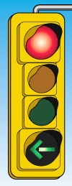 | 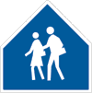 | 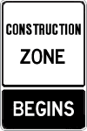
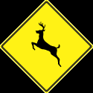 |  | 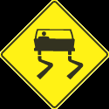
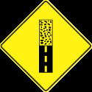 | 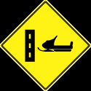 | 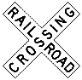
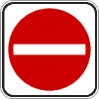 | 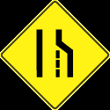 | 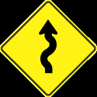

7 Traffic Sign Cards
8. Deer on the Road

Activity 8

Purpose:
- to realize and understand safety issues with deer in Manitoba
- to improve reading comprehension skills
- to improve listening and speaking skills through guided discussion questions
- to find embedded imperatives

CLB Level:
3/4

Time:
30 minutes

Materials:
- Word and Definition Cards – one set for the class
- Deer on the Road worksheet for each learner
- Deer on the Road Vocabulary and What’s the Imperative worksheet for each learner

Instructions:
1. Explain how driving in Manitoba changes during the different seasons. Emphasize that October and November are the months when deer are most active.

- Hand out the Deer on the Road text.
Pre-Reading Strategies:
A. Look at the pictures and ask learners to explain what they mean and what they think the text will be about.
B. Write the new words on the board and have learners find them in the text. Circle them and discuss in pairs what the possible meaning could be. Use one set of the Word and Definition cards and distribute them among the learners. Half the class should have words and half the class should have definitions. Learners circulate and find their partner. Have learners confirm their vocabulary/definitions with the class.
or C. Use the Deer on the Road Vocabulary worksheet
as an alternative, as a confirmation to Pre-Reading
Strategy B., or as homework.

3. Read the text together. Give Tips 1 and 2 card to one learner in the pair and Tips 3 and 4 card to the other. Have the learners ask and answer the questions.

4. Explain that imperatives are verbs that give the idea that a person should do something. Give examples on the board such as: Listen to me. Write your name on the paper. Turn off the lights, please. Drive carefully! It’s raining. Have the learners find words that are like imperatives in the reading and underline them. Examples for Tip 1are: Watch for deer signs, slow down, look in the ditches, look for eyes.

5. Hand out the What’s the Imperative worksheets if you have not used the Deer on the Road Vocabulary section. Have the learners match the first word of the sentence with the remainder of the sentence. If there are some more advanced learners have them fold over the words and complete the sentences. Go over the sentences practicing correct intonation of the more imperative imperatives.

1. collision | drive or run into something
2. tip | a good idea
3. deer population | number of deer in one place at the same time
4. roll-over | a vehicle goes on its side, top, side, bottom
5. driving experts | professional people who talk about the best way to drive
6. flash your headlights | turn your bright lights off and on a few times
7. area | a section of ground (metre, acre, hectare)
8. lose control | cannot control what vehicle does
9. windshield | the window in front of a vehicle
10. hood | piece of metal above the engine in a vehicle

8 Word and Definition Cards


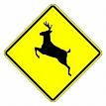
Deer on the Road
Do
NOT
Swerve

Manitoba drivers hit approximately 10,000 wild animals with their vehicles each year.

Sixty-five to eighty percent of these collisions are because of deer.

The months of October and November are the worst months for animal collisions.

Most of these collisions happen in the early evening and early morning.

Here are some tips:

1. Watch for deer signs while you are driving. These areas have a higher deer population. Slow down in these areas. Look in the ditches for deer that are feeding beside the road or that want to cross the road. At night, look for eyes shining in the dark.

2. Drive carefully, especially at night, in the early evening and early morning because this is when deer are the most active.
3. If you see a deer on the road, the safest things to do are to stay in your lane and try not to swerve. If you do swerve, you could have a roll-over, lose control of your vehicle or have a collision with another vehicle. Driving experts say that most deer are small enough that if you do hit one, it will hit the hood and continue up over the windshield instead of through the windshield.
4. Flash your headlights to let other drivers know that you see deer on or by the road.

Questions for Tips 1 and 2 Questions for Tips 3 and 4
1. Why should you watch for deer 1. What is the safest thing to do if you
signs? see a deer on the road?
2. Where should you look for deer? 2. Why shouldn’t you swerve?
3. Why are deer in ditches? 3. What happens to the deer when it is hit?
4. What should you look for at night? 4. Why don’t deer go through the
5. When are deer more active? windshield?
5. What should you do to let other
drivers know that there are deer on
the road?
8 Deer on the Road worksheet
Deer on the Road Vocabulary

Match the following vocabulary words with the definitions.
1. area ___ a. turn your bright lights off and on a few times
2. collision ___ b. a vehicle goes on its side, top, side, bottom
3. deer population ___ c. a good idea
4. driving experts ___ d. drive or run into something
5. flash your headlights ___ e. a section of ground (metre, acre, hectare)
6. hood ___ f. the window in front of a vehicle
7. lose control ___ g. number of deer in one place at the same time
8. roll-over ___ h. piece of metal above the engine in a vehicle
9. tip ___ i. can not control what a vehicle does
10. windshield ___ j. professional people who talk about the best way
to drive

What’s the Imperative?
Use these words to complete the sentences.
Be Don’t Don’t Drive Flash Hurry Look Slow Turn Wake

1. ________ down! There are deer in the ditch.
2. _________ up! It’s 7:00 a.m.
3. _________ out! You’re going to hit that car.
4. _________ up! We’re going to be late.
5. _________ carefully! It’s icy!
6. _________ swerve! You could have a roll-over.
7. _________ your headlights when you see deer.
8. _________ off the lights.
9. _________careful! If you see one deer, you will probably see two or three deer.
10. ________ speed! There are too many deer in this area.
8 What’s the Imperative worksheet
9. Keeping Deer Off Your Property

Activity 9

Purpose:
- to understand some of the problems with deer in Manitoba
- to improve reading comprehension skills
- to improve listening and speaking skills through sharing ideas

CLB Level:
4

Time:
20 minutes

Materials:
- Keeping Deer Off Your Property text for each learner
- Find the Word for the Definition and Review worksheet
for each learner

Instructions:

1. Discuss the problems Manitoba has with deer. If possible, provide pictures with, for example, half eaten cedar, damaged trees, crop damage, etc.

2. Hand out the Find the Word for the Definition worksheet to each learner. In pairs or as a class read the definitions and find the word. Repeat the vocabulary words and definitions as needed for pronunciation. Hand out the Keeping Deer Off Your Property text and have the learners find the vocabulary words in the article.

4. In pairs have the learners take turns reading the text and then have them find the phrases in the Review half of the worksheet that are not true.

5. Divide the class into groups of 3 or 4. Have the learners discuss other methods that would work to keep deer out. They may think of what they do for other animals which may also be a good idea to use with deer.

Keeping Deer off Your Property


Deer are beautiful to look at but they can be a problem.
1. Deer sometimes damage gardens, shrubs or fruit trees.
2. Deer sometimes cross roads and collide with vehicles.
3. Deer also carry deer ticks, which could be dangerous to
a person’s health. Lyme disease, a disease that affects
muscles and bones is often caused by deer ticks.

Here are a few tips to keep deer off your property:

1. Do not feed the deer.
Deer can find enough natural food without the help of people.
- When people feed deer, the deer population increases. If the deer population is too high, the deer can begin to starve and can often carry diseases.
- Deer become less afraid of people. They become less afraid to cross roads.
- When there are more deer, there is more damage to property.

2. Repellents
Repellents keep animals away because of its terrible smell or taste. Some repellents work and some don’t. Here are two recipes that seem to work well.

Recipe 1 Recipe 2
Mix 7 eggs with 4 cups of water. 1 teaspoon liquid dish detergent
Beat well. 2 Tablespoons hot sauce
Spray on plants. 4 cups of water
Spray on plants.
(These should be sprayed on every 30 days. These recipes also help keep rabbits out of your garden.)

3. Fences
The best way to keep deer off your property or out of your gardens is to put a fence around your whole yard or garden. The fence should be about eight feet high. A wooden fence, a snow fence or chicken wire all help. Fences can be an expensive way to keep deer off your property but if you want to keep your yard beautiful, it’s probably worth it. Another good idea is to put burlap around shrubs in winter.

9 Keeping Deer Off Your Property text
Match the words in the box below with the definition.

afraid burlap collide damage
deer population property snow fence spray tip

1. ___________________________________ your land or your lot
2. ___________________________________ hurt, break or makes less valuable
3. ___________________________________ drive or run into something
4. ___________________________________ a good idea
5. ___________________________________ scared
6. ___________________________________ number of deer in an area
7. ___________________________________ spray
8. ___________________________________ something that helps keep snow off
your driveway
9. ___________________________________ a rough brown material

Circle the phrase in each statement that is NOT true.

1. Deer are a problem because
a. they eat plants.
b. they walk on roads.
c. they damage houses.
d. they carry insects that cause Lyme disease.
2. When people feed deer
a. the deer population increases.
b. the deer are less afraid of people.
c. the deer are afraid to cross the road.
d. the deer do not look for their own food.
3. Repellents
a. always work.
b. have a terrible smell or taste.
c. need to be sprayed on every month.
d. keep other animals out of your garden.

4. Fences
a. are the best way to keep deer off your property.
b. that are low will keep deer off your property.
c. should go around your whole property.
d. are worth it if you like to have a beautiful yard.
9 Find the Word for the Definition and Review worksheet
10. How to Dress for Winter Fun

Activity 10

Purpose:
- to review clothes and body parts
- to learn clothing vocabulary specifically for winter
- to make sentences using the conjunctions “and” and “because”

CLB Level:
2/3

Time:
20 minutes

Materials:
- How to Dress for Winter text for each learner
- Optional: Articles of winter clothing

Instructions:

1. Have a discussion on cold winters. Are your jackets warm enough? Are your boots warm enough?, etc. Explain the word, enough.

2. Review basic body parts and winter clothes items.

3. Hand out the text, How to Dress for Winter worksheet, to each learner. Have the learners look at the picture of a woman getting dressed in layers for outside activities.

4. Read number 1 and discuss layers.

5. Have learners skim the text and look for body parts and clothing as per instructions.

6. Read the text together, one point at a time. Optional: Demonstrate with articles of winter clothing you have brought from home.

7. Have the learners complete the sentences in section 3 with the conjunctions and (co-ordinating) or because (subordinating). Because answers, “Why?”

8. Have the learners give sentences using “and” and “because”. Have learners write them down as a spelling exercise. Write the sentence on the board and allow them to correct their work. You may want to write the sentence down using blanks and some more difficult words. For example, __ winter, ___ _____ ____ read _____ and _____________. In winter, I like to read books and magazines.

How to Dress for Winter Fun

- Look at the picture below. Discuss the different clothing.

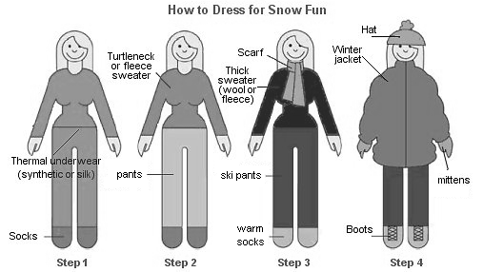

2. Read the text. Underline the body parts and circle the words that are clothing.
1. Wear layers of clothing.
2. Wear long underwear.
3. Wear an extra pair of socks.
4. Wear mittens. They are warmer than gloves. They should be thick. They should be big enough to wear an extra pair underneath. They should be long enough to cover your wrists.
5. Wear a hat that covers your ears. A lot of body heat is lost through your head.
6. Wear a scarf that covers your neck and chest. On cold days, you can use it to cover your face.
7. Wear winter boots that have a flat or low heel. They should be big enough to wear an extra pair of thick socks. You should have enough room to wiggle your toes.
8. Wear a long jacket or parka that goes down to your knees. It should have a warm lining. It should be big enough to wear an extra sweater.

3. Combine sentences with and or because.

1. Wear long underwear _____________ an extra pair of socks.
2. Wear mittens _______________ they are warmer than gloves.
3. Mittens should be thick _____________ long enough to cover your wrists.
4. Wear a hat that covers your ears ______________ a lot of body heat is lost through the
head.
5. Wear a scarf that covers your neck and chest _______________ on cold days, you can
use it to cover your face.
6. Winter boots should have a flat or low heel ________________ be big enough to wear an extra pair of socks.
7. A parka should have a warm lining _____________ be big enough to wear an extra
sweater. 10 How to Dress for Winter Fun worksheet

11. Understand Blizzards

Activity 11

Purpose:
- to learn about winter storms and blizzards
- to build vocabulary using a dialogue

CLB Level:
3

Time:
30 minutes

Materials:
- Winter Weather Vocabulary cards for each pair of learners
- Understand Blizzards and Caught in a Blizzard worksheet for each learner

**Photocopy cards on cardstock and laminate for future use**

Instructions:

1. Discuss Winter as a class. Make a list of what they like and what they don’t like on the board.

2. Show pictures of snowstorms and have learners describe what they see. Try to illicit vocabulary such as cold, ice, snow, wind and dangerous should be included.

3. Hand out Winter Weather Vocabulary cards. Go over new vocabulary, pronouncing new words and definitions. In pairs, have the learners review vocabulary words together matching definitions, words and pictures.

4. Hand out Understand Blizzards and Caught in a Blizzard worksheet to the learners. Have learners fill in the blanks for the first section and review.

5. Look at the dialogue Caught in a Blizzard. Explain the title. Explain that you are going to read the dialogue as they fill in the blanks. Read it 2 or 3 times. Write the vocabulary words on the board for them to check their answers and spelling.

6. Go through the dialogue for comprehension.

7. Have the learners practice in pairs and present the dialogues to class.

8. Have the learners share experiences they have had driving in storms—in some cases, rain storms may need to be included.

Answer Key: Understand Blizzards
1. blizzard | 2. wind chill | 3. high or strong winds
4. blowing | 5. heavy snowfall | 6. whiteout
7. sleet | 8. snowdrift | 9. slippery
Answer Key: Caught in a Blizzard
1. high | 2. snow | 3. whiteout
4. blowing | 5. slippery | 6. snowdrift

blizzard | The most dangerous type of winter storm. There is lots of snow and the wind blows more than 40 kilometres per hour. The temperature feels like -25°C or more. | 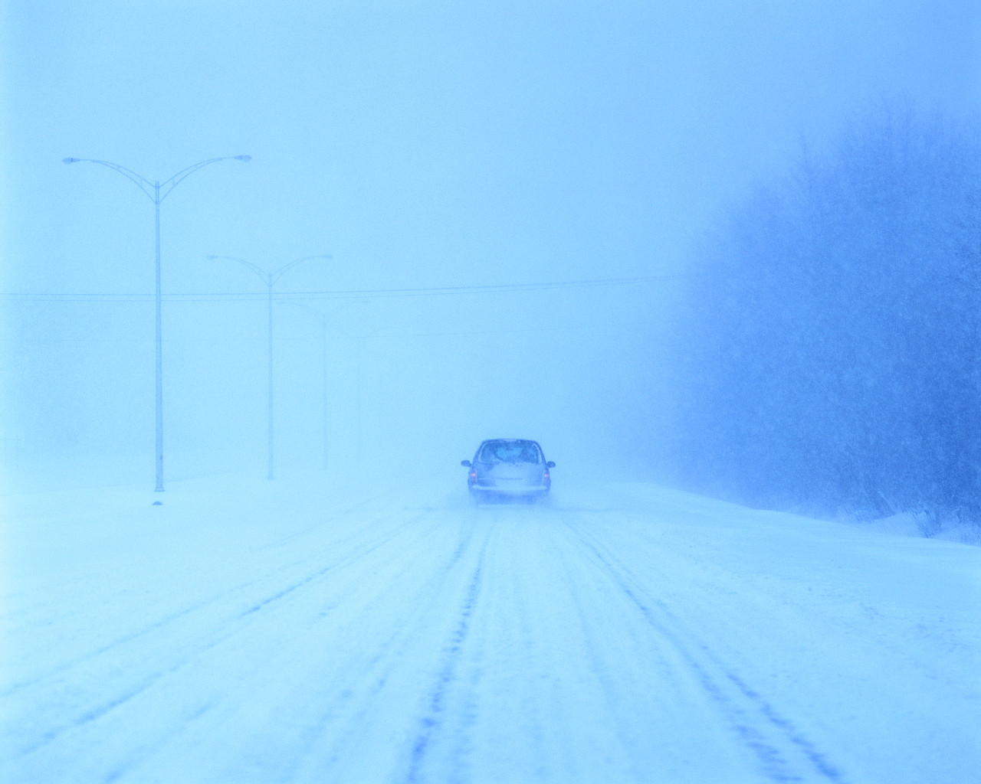
blowing | You see air moving something. | 
heavy snowfall | A lot of snow falls in a short time. | 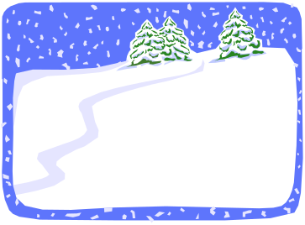
high/strong winds | The wind blows fast. | 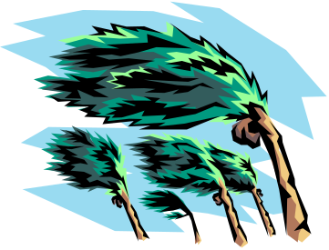
sleet | Snow and rain fall at the same time. | 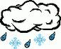

11 Winter Weather Vocabulary cards

slippery | When roads are wet or icy they make you slip or slide. | 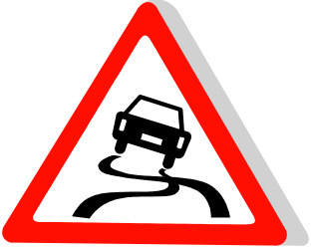
snowdrift | When the wind blows and makes a small hill of snow. | 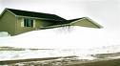
whiteout | When the wind blows and it snows a lot. All you can see is white snow. | 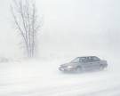
wind chill | How low temperatures plus wind feel on the skin. | 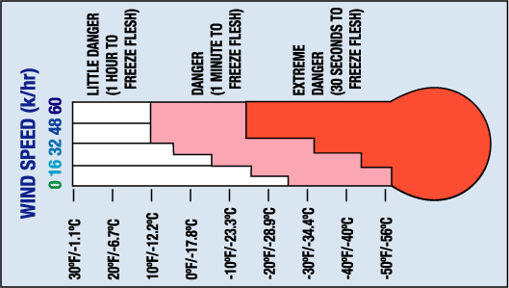

11 Winter Weather Vocabulary cards

Understand Blizzards

Fill in the blanks using these words:
blizzard blowing heavy snowfall
high or strong winds sleet slippery
snowdrift wind chill whiteout

1. A winter storm with lots of snow and wind that blows more than 40 kilometres an hour is a ____________________________.
2. The ________________________ is low temperature plus wind.
3. __________________________ winds are fast winds.
4. A _________________ wind makes us see leaves moving in the trees.
5. When a lot of snow falls, it is called a ____________________________.
6. In a ____________________ you can’t see across the street.
7. Rain and snow that fall at the same time is called __________________.
8. When wind piles up snow, it is called a __________________________.
9. If a road or sidewalk is icy and we think we will fall, we say that it is _____________.

Caught in a Blizzard
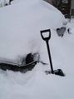
Joanne: Did you hear that we’re supposed to get a heavy snowfall
on Friday?
Ben: Yes. I hope it doesn’t turn into a blizzard like the one we
had in 1997.
Joanne: What happened?
Ben: Well, it was very cold and there was a lot of snow. The
worst part was the ______________ winds.
Joanne: Was it dangerous driving?
Ben: Yes. The snow was blowing everywhere and I couldn’t see the cars in front of
me. It was a _____________________. I had to stop and wait for the wind to
stop _________________.
Joanne: How were the roads?
Ben: The roads were _______________. I saw three or four cars in the ditch.
Joanne: Did you make it home OK?
Ben: Yes, I did but the next morning my car was buried in a ______________.
I had to dig it out.
Joanne: Well, I’m glad you made it home. 11 Understand Blizzards and Caught in a Blizzard worksheet

12. Frostbite and Blizzards

Activity 12

Purpose:
- to read for understanding
- to build vocabulary
- to summarize information
- to ask questions to confirm understanding

CLB Level:
4+

Time:
30+ minutes

Materials:
- Frostbite Treatment Reading and Questions sheet cut in half for half the class
- Blizzards in Manitoba Reading and Questions sheet cut in half for half the class

** It is interesting to note how well they remember what they have read after an activity such as this.**

For more articles and ideas check:
http://bogglesworldesl.com/teaching_articles1.htm

Instructions:

1. Have a discussion on what they like and what they don’t like about winter. Make a list of on the board.

2. In general terms, discuss frostbite and blizzards.

3. Divide the class in half. Hand out Frostbite Treatment text to one half and the Blizzards text to the other half. (Give the Blizzards Reading to lower level readers.)

4. Have the learners underline the following words in the Frostbite text. Discuss the meaning of any unfamiliar words.
frostbite cause exposed thaw re-expose sensations sterile

5. Have the learners underline the following words in the Blizzards text. Discuss the meaning of any unfamiliar words. invisible closed down piece of advice

6. Learners who have the Frostbite text are divided into pairs. Learners who have the Blizzards text are divided into pairs. Hand out the corresponding question sheet to each pair. Frostbite pairs would have Frostbite questions and Blizzard pairs would have Blizzard questions. Have them work in pairs to answer the questions about the text.

7. Have the learners hand in all the readings and questions.

8. Form new pairs with one Frostbite learner and one Blizzard learner together. Hand out the Frostbite questions to the Blizzard learner and the Blizzard questions to the Frostbite learner. Learners quiz each other on their given texts.

9. After everyone has shared their information, give them a quick quiz to ensure understanding.

Frostbite Treatment  Extreme cold can cause frostbite to exposed skin. This is a serious condition that requires emergency care.  Your hands, feet and face are the parts of your body that most often get frostbite. This causes an aching pain or numbness in the affected area. The skin feels hard and has a white, waxy or purplish appearance.  If you can’t get immediate medical treatment, go inside. Do not try to thaw frostbite unless you are able to stay in a warm place. Warming and re-exposing frozen parts to cold can cause permanent damage.  Remove any wet clothing. Most people make the mistake of wanting to rub the frozen body part but this is a mistake. Do not rub them because this may cause more damage. Rather warm the frozen part in warm water (37.7°C – 40.5°C) for 30 minutes or longer until the skin is soft and feeling sensations come back. Do not use dry heat such as a fireplace, oven or heating pad. As well, remember to warm the rest of the body with blankets or warm clothes.  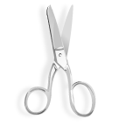  If the fingers or toes have been frozen put cotton balls or anything else sterile between them. As the frozen areas warm there will be some severe burning sensations, change of skin colour and maybe blistering or swelling. Take some ibuprofen for pain. | Frostbite Treatment Questions  What is the title of the article?  What causes frostbite?  Where does a person most often get frostbite?  How does the skin feel?  How does the skin look?  Why should you not thaw frostbite if you can’t stay inside?  What is the mistake most people make in taking care of a frozen body part?  How should you warm the frozen part?  What types of dry heat should you not use?  Where could you use cotton balls?  What happens as the frozen body parts warm up?  Should you take anything for pain?
12 Frostbite Treatment Reading and Questions

Blizzards in Manitoba  One November a terrible blizzard hit southern Manitoba.  Green grass was suddenly covered by 45 centimetres of snow. The wind blew up to 90 kilometres per hour. People were almost invisible in the blowing snow. Cars and buses got stuck in the snow. Schools, offices and factories closed down. Everybody stayed inside. Luckily, no one died.  A blizzard is an extremely bad snowstorm.  - There is blowing snow. You cannot see easily across the street. Visibility is less than 1 kilometre.  - The wind blows more than 40 kilometres per hour.  - The temperature feels like -25°C or more. Skin can freeze quickly.  - The weather conditions last for more than 6 hours.  What should you do? The greatest piece of advice is to stay inside! Listen to the radio for blizzard warnings. If you have to travel, make sure your vehicle is equipped with emergency supplies.  Some things to take along are:  -- extra clothes and blankets  -- a shovel -- a bottle of water  -- candles and matches  -- a cell phone  -- canned or dry food  Make sure someone knows where you are going and when you plan to arrive. | Blizzards in Manitoba Questions  What is the title of the article?  Where did the blizzard occur?  How bad was it?  Did anyone die?  Name three things about a storm that make it a blizzard?  a)  b)  c)  What is the most important thing to do in a blizzard?  Name at least four supplies you should have in your vehicle?  1)  2)  3)  4)  What else is important to remember to do?
12 Blizzards in Manitoba Reading and Questions

13. Keep a Travel Kit

Activity 13

Purpose:
- to learn what to keep in vehicles for winter
- to build vocabulary

CLB Level:
3

Time:
15- 20 minutes

Materials:
- a set of picture and word cards for each pair of learners OR
A Travel Kit worksheet for each learner
- Keep a Travel Kit in Your Vehicle worksheet for each learner
- Answer Key OHT

Instructions:

1. Brainstorm items the learners keep in their vehicles during the winter and why it is important to do so. Make a list on the board.

- 2. There are two versions of the same activity here. Choose one.
- Hand out a set of pictures and word cards to each pair of learners. Have them match them. Use the Answer Key OHT for the learners to correct their matches.

or B. Hand out A Travel Kit worksheet to each learner.
Have learners match the pictures with the vocabulary
words.

4. Hand out the Keep a Travel Kit in your Vehicle worksheet to each learner and have them answer the questions.

5. Discuss as a class the answers to the questions.

Answer Key:
1. Keep (1) jumper cables in your car to boost your battery.
2. Keep (2) windshield washer fluid in your vehicle to clean the windshield while you are driving.
3. Keep (3) sand in your vehicle to give you traction if you are stuck.
4. Keep (4) an ice scraper and snow brush in your vehicle to scrape ice off the windows.
5. Keep (5) a blanket, (6) extra clothes and (7) a candle in a can and matches in your vehicle to keep you warm while you are waiting.
6. Keep (8) a flashlight in your vehicle to see in the dark or get attention.
7. Keep (9) snacks and bottled water in your vehicle so you don’t get hungry.
8. Keep (10) a cell phone in your vehicle so you call for help.
9. Keep (11) a first aid kit in your vehicle so that if someone is hurt you can give them some help.
10. Keep (12) a shovel in your vehicle to help you if you are stuck.

A Travel Kit

Driving in winter can be dangerous. Keep these things in your vehicle.

Match the words and the picture. Write the number under the picture.

Pictures Words
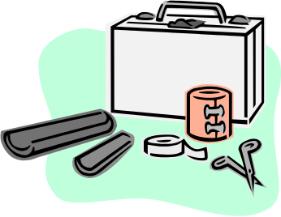
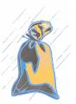
1. sand
2. windshield washer fluid
3. extra clothes
4. jumper cables
5. blanket
6. cell phone
7. ice scraper and snow brush
8. candle in a can and matches
9. snacks and bottled water
10. first aid kit
11. flashlight
12. shovel


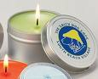
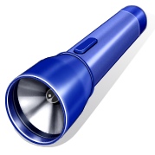


_____________________________
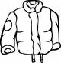

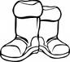

Which items will you put in your
vehicle?
__________________________
__________________________
__________________________

13 A Travel Kit

____________________________________

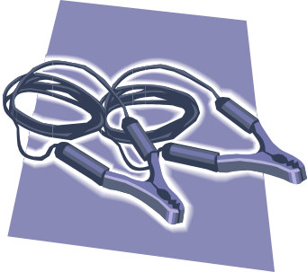


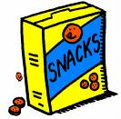
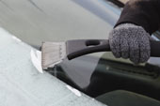



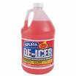

13 Picture Cards

1. first aid kit | 2. sand | 3. flashlight
4. candle in a can and matches | 5. snacks and bottled water | 6. blanket
7. extra clothes | 8. windshield washer fluid | 9. shovel
10. jumper cables | 11. cell phone | 12. ice scraper and snow brush

13 Word Cards

Keep a Travel Kit in Your Vehicle

Fill in the blanks with items you should keep in your vehicle during the winter.

1. Keep ______________________________ in your car to boost your battery.

2. Keep ________________________________________ in your vehicle to clean the windshield while you are driving.

3. Keep _________________________________ in your vehicle to give you traction if you are stuck.

4. Keep ___________________________________ in your vehicle to scrape ice off the windows.

5. Keep ________________________, ___________________________
and ________________________________________ in your vehicle to keep you warm while you are waiting.

6. Keep ___________________________________ in your vehicle to see in the dark or get attention.

7. Keep __________________________________________ in your vehicle so you don’t get hungry.

8. Keep ____________________________________ in your vehicle so you call for help.

9. Keep __________________________________________ in your vehicle so that if someone is hurt you can give them some help.

10. Keep ____________________________ in your vehicle to help you if you are stuck.

13 Keep a Travel Kit in your Vehicle worksheet
 | 1. first aid kit |  | 2. sand
 | 3. flashlight |  | 4. candle in a can and matches
 | 5. snacks and bottled water |  | 6. blanket
 | 7. extra clothes |  | 8. windshield washer fluid
 | 9. shovel |  | 10. jumper cables
 | 11. cell phone |  | 12. ice scraper and snow brush

13 Picture and Word Card Answer Key OHT
14. I’m Freezing!

Activity 14

Purpose:
- to improve pronunciation and intonation skills
- to build vocabulary using a dialogue

CLB Level:
3+

Time:
10 minutes

Materials:
- I’m Freezing! dialogue for each learner
- Sentence Strips for the learners
- Fill in the Blank worksheet for each learner

Instructions:

1. Use this dialogue as part of a Winter Theme.

2. Hand out the I’m Freezing! dialogue to each learner. Read over the dialogue together as a class. Learners repeat each line for pronunciation and intonation.

3. Go over the vocabulary.

4. Explain that memorization helps with pronunciation, intonation and the “feel” of the English language.
Give the learners one week to memorize it.

5. During the week, give learners Sentence Strips or the Fill in the Blank worksheet to help with memorization.

6. Write the following words on the board for the learners to use for the “Fill in the Blanks” exercise.
should better cold heard extra
freezing thought sure Once boots

Dialogue: I’m Freezing!
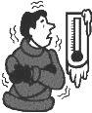
A: Oh, man! Is it cold out, today!
B: No kidding! I’m freezing! What’s the temperature?
A: I heard that it’s supposed to be -24 Celsius.
B: I’m sure it’s colder than that. My feet are frozen.
A: Your boots don’t look very warm.
B: They’re not. Next time I’ll buy a warmer pair.
A: A heavier pair of socks helps, too.
B: Thanks. I never knew that winter was so cold.
A: Once it reaches -10, you have to be careful you don’t get frostbite.
B: I think I’ll look for a warmer pair of mittens, too.



Dialogue: I’m Freezing!
A: Oh, man! Is it cold out, today!
B: No kidding! I’m freezing! What’s the temperature?
A: I heard that it’s supposed to be -24 Celsius.
B: I’m sure it’s colder than that. My feet are frozen.
A: Your boots don’t look very warm.
B: They’re not. Next time I’ll buy a warmer pair.
A: A heavier pair of socks helps, too.
B: Thanks. I never knew that winter was so cold.
A: Once it reaches -10, you have to be careful you don’t get frostbite.
B: I think I’ll look for a warmer pair of mittens, too.

14 I’m Freezing! Dialogue

Oh, man! Is it cold out, today!
No kidding! I’m freezing! What’s the temperature?
I heard that it’s supposed to be -24 Celsius.
I’m sure it’s colder than that. My feet are frozen.
Your boots don’t look very warm.
They’re not. Next time I’ll buy a warmer pair.
A heavier pair of socks helps, too.

Thanks. I never knew that winter was so cold.

Once it reaches -10, you have to be careful you don’t get
frostbite.
I think I’ll look for a warmer pair of mittens, too.

14 I’m Freezing ! Sentence Strips
I’m Freezing!
Fill in the blanks with the words on the board:

A: Oh, man! Is it __________________ out, today!
B: No kidding! I’m ____________________! What’s the temperature?
A: I _________________ that it’s supposed to be -24 Celsius.
B: I’m _________________ it’s colder than that. My feet are frozen.
A: Your ___________________ don’t look very warm.
B: They’re not. Next _________________I’ll buy a warmer pair.
A: A. _____________________ pair of socks helps, too.
B: Thanks. I never ______________________winter was be so cold.
A: ___________ it reaches -10, you have to be careful you don’t get frostbite.
B: I think I’ll look for a warmer pair of __________________, too.



I’m Freezing!
Fill in the blanks with the words on the board:

A: Oh, man! Is it __________________ out, today!
B: No kidding! I’m ____________________! What’s the temperature?
A: I _________________ that it’s supposed to be -24 Celsius.
B: I’m _________________ it’s colder than that. My feet are frozen.
A: Your ___________________ don’t look very warm.
B: They’re not. Next _________________I’ll buy a warmer pair.
A: A. _____________________ pair of socks helps, too.
B: Thanks. I never ______________________winter was be so cold.
A: ___________ it reaches -10, you have to be careful you don’t get frostbite.
B: I think I’ll look for a warmer pair of __________________, too.

14 Fill in the Blanks worksheet
15. I Locked the Keys in My Car

Activity 15

Purpose:
- to learn the pronunciation of -ed endings
- to read for content
- to understand problem-solving skills

CLB Level:
2/3

Time:
30 minutes

Materials:
- Pronunciation of –ed Endings worksheet for each learner
- My Keys Are in the Car worksheet for each learner

Instructions:

1. Using the pronunciation of -ed endings worksheet, discuss with the class the pronunciation of –ed verbs, giving several examples of past.

2. Divide the class into pairs and hand out the pronunciation of -ed endings worksheet. Go through the pronunciation exercise once the class has finished the worksheet.

3. Hand out the My Keys Are in the Car text to the learners. Have them find and underline the past –ed verbs

4. Have the learners take turns reading the text to a partner listening for the –ed pronunciation.

5. Ask questions about general content from the story. Does your car ever stall? Have you ever left your keys in the car? What do you think this person should do?

6. Have a discussion on different options this person would have to do for getting the keys out of the car.
Check the CAA Manitoba website, www.caamanitoba.com as an example of a service available for roadside assistance. Credit cards may offer this as well.

PRONUNCIATION OF ‘-ED’ ENDINGS

The past – something that started in the past and finished in the past.
Example: Last night I phoned my brother.

1. To make the past, add ‘-ed’ to the verb. cook + ed = cooked
Example: I usually cook supper.
Last night my husband cooked supper.

2. When the verb ends with ‘-e’ just add ‘-d’ to make the past.
Example: I live in Steinbach now.
Last year I lived in Calgary.

3. When the verb ends with ‘-y’ change the ‘-y’ to ‘-i’ and add ‘-ed’.
Example: I try to speak English every day.
Last year I hardly ever tried.

Pronunciation of ‘-ed’ Endings:

1. ‘-ed’ sounds like /d/ after /t/ or/d/.
wanted wan-ted needed nee-ded

2. ‘-ed’ sounds like /t/ after /f/, /k/, /p/, /s/, /x/, /sh/, /ch/ sounds.
fixed cooked worked

3. ‘-ed’ sounds like /d/ after all the other sounds.
lived phoned played

What does the verb sound like?
/d/ | /t/ | /d/

1. I ___________ (watch) TV last night.
2. I ___________ (clean) the garage last week.
3. I ___________ (walk) to work on Friday.
4. I ___________ (paint) the house last weekend.
5. I ___________ (want) to go to Winnipeg last night.
6. I ___________ (live) in Mitchell last year.

15 Pronunciation of –ed Endings
Read these sentences. Put a check (✓) for the sound in the chart on the right.
/d/ | /t/ | /d/
✓

1. I started (start) the car.
2. I _________________ (scrape) the windshield.
3. I _________________ (brush) the snow off the hood.
4. I _________________ (want) to back up.
5. It ________________ (stall).
6. I _________________ (press) on the accelerator.
7. I _________________ (park) the car.
8. I _________________ (open) the door.
9. I _________________ (look) for my keys.
10. I _________________ (realize) they were in the car.
11. I _________________ (walk) the five blocks.
12. I _________________ (deposit) my cheque.
13. I _________________ (worry).



My Keys Are in the Car

Yesterday was cold. It was -18°C but with the wind chill it felt like -25°C. I started the car at 7:30 a.m. and let it run for ten minutes. I scraped the ice off the windshield and brushed the snow off the hood. I was ready to go but when I wanted to back up, it stalled. I started it again and pressed on the accelerator to give it some gas. I tried again. This time it didn’t stall.

I drove to work in Steinbach. I parked the car in the parking lot. I worked until noon. I wanted to go to the bank over my lunch hour. I opened the door and walked out of the building and to the car. I looked for my keys in my purse but I couldn’t find them. Then I realized they were locked in the car. Well, what could I do?

I tied my scarf around my neck and walked the five blocks to the bank. It was cold. I wasn’t dressed for walking. I deposited my cheque and hoped I wasn’t too late for my mortgage payment. I walked back to work and worried about how I would get the keys out of the car.

15 My Keys Are in the Car worksheet
16. Winter Conversations

Activity 16

Purpose:
- to improve speaking and listening skills
- to share opinions and ideas

CLB Level:
3+

Time:
10 minutes

Materials:
- a set of Winter Conversation cards for each group

Instructions:

1. Use the Winter Conversation cards after you have had a discussion about winter and have done one or two winter activities in the Be Safe Unit.

2. Divide learners into groups of 3 or 4. Hand out the question cards to the group. Encourage learners to share stories. Learners take turns reading their questions and as a group have a one-minute discussion. Learners then move on to the next question.

3. As learners discuss move around the classroom and listen for new vocabulary learned, turn taking strategies, and correct use of the past in storytelling. Ask questions and help learners along if they are shy or struggling with the questions.

4. Cards may be eliminated or changed to suit the class.

What kind of clothing do you wear in winter? | Are you looking forward to winter? Why or why not?
How do you get your car ready for winter? | Do you put anything extra in your car in winter?
What is a blizzard?  Have you been in a blizzard? What was it like? | What is frostbite?  Have you had frostbite? How did it happen?
What temperature is cold for you? What do you do when it is freezing outside? | Do you listen to the weather forecast? If yes, when?
How do you feel when you drive on icy roads? Have you hit the ditch? | What was winter like in your home country?
What are some fun things you can do in winter? | Do you think people sleep more in winter?

16 Winter Conversation Cards

