Housing

Activity | Purpose | Page
1 | My Dream House  - to build vocabulary in describing a house | 2
2 | Looking for a House  - to learn the spelling and use of comparative adjectives  - to use adjectives to describe homes  - to use Real Estate flyers or a local newspaper to compare houses | 4
3 | House-Hunting  - to listen for details in a telephone conversation  - to listen for details in buying a house  - to use comparisons | 8
4 | Sara’s New House  - to understand vocabulary related to looking for a house  - to improve reading comprehension skills  - to review the past tense | 12
5 | Is It Big Enough?  - to reinforce learner’s use of too, very, enough, not enough | 16
6 | Applying for a Mortgage/Loan  - to become familiar with general banking terms  - to learn how to apply for a loan or mortgage | 19
7 | Donna’s Nightmare  - to understand vocabulary words for flooding problems  - to find present perfect tense sentences | 23
8 | A House Nightmare  - to identify plumbing problems in a house  - to communicate plumbing problems | 28

- My Dream House

Activity 1

Purpose:
- to build vocabulary in describing a house

CLB Level:
2/3

Time:
15 minutes

Materials:
- My Dream House worksheet for each learner

Instructions:

1. Brainstorm ideas of a perfect house.

2. Hand out My Dream House worksheet to each learner. Go over the vocabulary words. Add any words the learners may have used to describe a house.

2. Review the use of a, an or nothing (-) before vocabulary words.

3. Have the learners write a paragraph describing their dream house. Learners can use simple sentences with has or would have. These forms can be introduced here.

My Dream House

Think about the kind of house you want. Look at the list of ideas to help you decide.
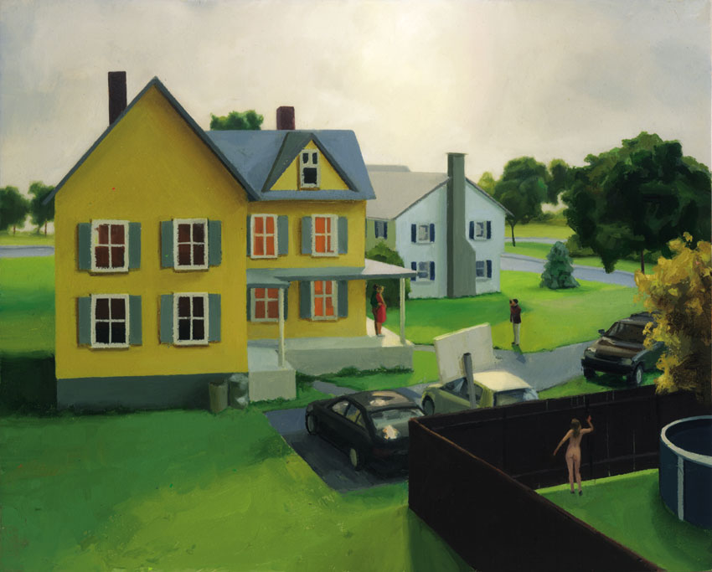
1. bungalow (one floor)
2. two-story (two floors)
3. new home
4. older home
5. central air
6. fireplace
7. how many bedrooms?
8. how many bathrooms?
-“full bathroom” means a sink, a shower/tub, and a toilet.
-“1/2 bath” means a sink and a toilet.
9. vinyl siding
10. stucco
11. brick accents 17. close to a school?
12. fence 18. close to shopping?
13. deck
14. trees
15. big yard
16. small yard

Describe the kind of house you would like to buy.
____________________________________________________________________________________________________________________________________________________________________________________________________________________________________________________________________________________________________________________________________________________________

- My Dream Home worksheet
2. Looking for a House

Activity 2

Purpose:
- to learn the spelling and use of comparative adjectives
- to use adjectives to describe houses
- to use Real Estate flyers or a local newspaper to compare houses

CLB Level:
2/3

Time:
30 minutes

Materials:
- Comparing Houses worksheet for each learner
- Adjective cards for each pair of learners
(Adapted from Grammar Dimensions 1)
- Real Estate flyers

(For each set of opposite adjective cards use a different colour of paper. It is much easier to separate the sets when different colours are used.)

- The Adjective cards can also be used for an activity on Opposites.

Instructions:

1. Explain how comparative adjectives are used by drawing a small object and a large object. A is bigger than A.

2. On the board make three columns:
-er than | more _____ than | _ier than

Explain how comparative adjectives are formed.
* One syllable words take on –er
e.g. nicer, smaller etc.
- One syllable words that are consonant, vowel, consonant take on the last consonant and then –er. e.g. bigger, hotter, etc.
* Two or more syllables take on more____
e.g. more beautiful, more comfortable, etc.
* Two syllable words that end with /y/: Change the /y/ to /i /and add –er (ier)
e.g. happy – happier, funny – funnier, etc.

3. Give a few examples of sentences emphasizing the use of “than” after the comparative.

4. Hand out the Adjective cards to pairs of learners. Have them put the adjectives into four piles:
–er | more __ than | -ier | irregular

Optional: Put the last 3 rows aside when cutting the adjective cards. Finish cutting the top section of the cards. Then cut the bottom section. Combine a different coloured bottom set with a different coloured top set. This makes the task a little easier to complete in a shorter time frame.

7. In pairs, learners make five sentences using the comparative form of the adjective.
e.g. This house is bigger than my old house.
The ceiling in the newer house is higher than the
ceiling in the older house.

8. Hand out Comparing Houses worksheets to learners. Look at the two advertisements as a whole group. Go over vocabulary. What do students like about the houses, what don’t they like?

9. Fill in the comparative adjectives in pairs. Do they agree with the statements? Make true statements out of the “No” answers by using opposite adjectives.

10. Learners look at Real Estate flyers or a local news paper. Assign each learner a page to look for a house and compare it to a house another learner has chosen.

Answer Key for Adjective Cards:
-er than | more____ than | -ier than | irregular + than
bigger | beautiful | easier | bad – worse
cheaper | boring | dirtier | good – better
cleaner | crowded | messier
closer | difficult | noisier
larger | expensive | roomier
nearer | horrible | uglier
neater | interesting
newer | modern
older | polluted
quieter | quiet*
safer | spacious
smaller | traditional
high
low
*most people prefer quieter

easy | difficult | high | low
beautiful | ugly | cheap | expensive
bad | good | clean | dirty
polluted | messy | neat | big
large | small | new | old
safe | dangerous | noisy | quiet
far | near | close to | fantastic
horrible | boring | interesting | modern
traditional | crowded | spacious | roomy

2 Adjective cards
Comparing Houses
You are looking for a new house. The realtor shows you these two. Compare the two.
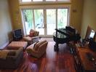  For Sale  Newer home on Pine Crescent. 2 ½ bathrooms. 2200 square feet. Quiet. Lots of light. $229,000  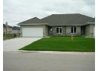 |   For Sale  Older one-bedroom house on First Street. 960 square feet. Central location. Close to bus stop and shopping centre. $89,900.  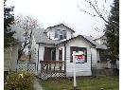

Read the statements below about these houses. |  |  | Yes | No
The house on Pine Crescent is … | 1. ___________________________  (small) | than the house on First Street.
The house on Pine Crescent is … | 2. ___________________________  (close) to the bus stop | than the house on First Street.
The house on Pine Crescent is … | 3. ___________________________  (far) away from the downtown area | than the house on First Street.
The house on Pine Crescent is … | 4. __________________________  (expensive) | than the house on First Street.
The house on Pine Crescent is … | 5. __________________________  (spacious) | than the house on First Street.
The house on Pine Crescent is … | 6. __________________________  (noisy) | than the house on First Street.
The house on Pine Crescent is … | 7. __________________________  (safe) | than the house on First Street.
The house on Pine Crescent is … | 8. __________________________  (convenient) | than the house on First Street.
The house on Pine Crescent is … | 9. __________________________  (sunny) | than the house on First Street.
The house on Pine Crescent is … | 10. ________________________  (quiet) | than the house on First Street.

I think the ______________________ is better because _________________.
2 Comparing Houses worksheet
3. House-Hunting

Activity 3

Purpose:
- to listen for details in a telephone conversation
- to listen for details in buying a house
- to use comparisons

CLB Level:
3

Time:
20 minutes

Materials:
- Dialogue 1: House-Hunting worksheet for half the class
- Dialogue 2: House-Hunting worksheet for half the class
- Discussion Questions for each group of learners (each page makes 3 copies)

Instructions:

1. Review housing vocabulary – bungalow, duplex, upstairs, downstairs, second floor, full bathroom, lot, pine trees, oak trees (pictures) and any other vocabulary necessary.

2. Discuss with the class what the term house-hunting means. Hand out Dialogue 1: House-Hunting to half the class. Hand out Dialogue 2: House- Hunting to the other half of the class. Learners who have Dialogue 1 pair up with another learner who has Dialogue 1 and practice the dialogue. Learners who have Dialogue 2 pair up with another learner who has Dialogue 2 and practice that dialogue. Circulate among pairs, giving definitions and pronunciation as needed.

- A partner pair with Dialogue 1 forms a group with a
partner pair that has Dialogue 2.
- Partner pair 1 presents their dialogue while Partner pair 2 listens and checks the statements that are true.
- Then Partner pair 2 presents their dialogue while partner pair 1 listens and checks the statements that are true.

3. With the same groups, hand out the Discussion Questions. Review the questions as a class and give an example of what a sentence could look like. Try to encourage learners to use comparatives.
Sample answers for Dialogue Questions:
1. The yard was bigger.
2. The houses were smaller.
3. I would have more trees.
4. Renting. There is less paperwork.

Dialogue 1: House-Hunting
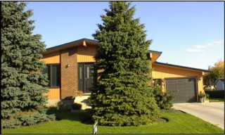
Sam: I’m calling about the house you have for sale.
Realtor: Which one?
Sam: The one on Tenth Street.
Realtor: O yes. The bungalow.
Sam: How old is it?
Realtor: It’s 15 years old.
Sam: How many bedrooms does it have?
Realtor: Let’s see. Three on the main level and one downstairs.
Sam: And how many bathrooms?
Realtor: There’s a 4-piece bathroom on the main level and a 2-piece bathroom downstairs.
Sam: How big is the lot?
Realtor: It’s 100 feet by 150. It has a beautiful yard with pine trees and a few oak trees in back. It’s also close to the elementary school . . . if you have children.
Sam: I’d like to see it today.
Realtor: Why don’t we meet there at 7:30?
Sam: How about 7:00?
Realtor: Sure. At 7:00. See you then.

Listen to the conversation and check (✓) the answers that are true.

1. The house for sale is on Fourth Street. | The house for sale is on Fifth Street.
2. The house is nine years old. | The house is five years old.
3. The house has one bathroom. | The house has one bathroom on the main level.
4. The yard has a flower garden and a fence. | The yard has a flower garden and a shed.
5. Carol thinks the house is a little small. | Carol thinks the yard is a little small.
6. The house is $115,900. | The house is $159,000.
7. The appointment is on Friday at 4:00. | The appointment is on Friday at 5:30.

3 Dialogue 1: House-Hunting
Dialogue 2: House-Hunting
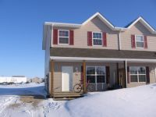
Carol: I’m calling about the house you have for sale.
Realtor: Which one?
Carol: The one on Fourth Street.
Realtor: O yes. The duplex.
Carol: How old is it?
Realtor: It’s 5 years old.
Carol: How many bedrooms does it have?
Realtor: Let’s see. Three.
Carol: And how many bathrooms?
Realtor: There’s a full bathroom on the second level.
Carol: How big is the lot?
Realtor: It’s 36 feet by 100. It has a beautiful flower garden and a shed in the back yard.
Carol: The yard is a little small. How much are you asking for the house?
Realtor: $115,900. Would you like to make an appointment to see it?
Carol: OK. How about on Friday at 4:00?
Realtor: Friday? Could we meet at 5:30?
Carol: OK 5:30. I’ll meet you there.

Listen to the conversation and check (✓) the answers that are true.
1. Sam is thinking about buying a house. | Sam is thinking about renting a house.
2. The house is on Tenth Street. | The house is on Seventh Street.
3. The house is fifty years old. | The house is fifteen years old.
4. The house has three bedrooms. | The house has four bedrooms.
5. The house has a 2-piece bathroom on the main level. | The house has a 2-piece bathroom downstairs.
6. The lot is 200 feet by 115. | The lot is 100 feet by 150.
7. It has a beautiful yard with trees. | It has a beautiful yard but no trees.
8. Sam and the realtor meet at 7:00. | Sam and the realtor meet at 7:30.
3 Dialogue 2: House-Hunting
Discussion Questions:

1. How was your last home better than the one you live in now?
How was it worse?

2. Were houses more environmentally friendly 50 years ago? Why or why not?

3. If you could change anything in your house what would it be?

4. Is it better to rent or buy? Why?
What are some advantages and disadvantages?

1. How was your last home better than the one you live in now?
How was it worse?

2. Were houses more environmentally friendly 50 years ago? Why or why not?

3. If you could change anything in your house what would it be?

4. Is it better to rent or buy? Why?
What are some advantages and disadvantages?

1. How was your last home better than the one you live in now?
How was it worse?

2. Were houses more environmentally friendly 50 years ago? Why or why not?

3. If you could change anything in your house what would it be?

4. Is it better to rent or buy? Why?
What are some advantages and disadvantages?

3 Discussion Questions
4. Sara’s New House

Activity 4

Purpose:
- to understand vocabulary related to buying a house
- to improve reading comprehension skills
- to review the past tense

CLB Level:
3

Time:
20 minutes

Materials:
- Sara’s New House text
- Multiple-choice worksheet for each learner
- Vocabulary Definition cards for each pair of learners

Instructions:

1. Learners discuss how they purchased their houses and how they furnished them – where did they shop, what did they buy, etc.

2. Hand out the Sara’s New House worksheet. Tell the class that this is a story about Sara. She decided to buy a house last month. This story is told in the past. Solicit irregular past tense verbs from the learners. Write the past tense vocabulary on the board or have the learners spell out the words. As a class find the –ed past verbs. See Answer Key below.

3. Depending on your level of class you can use the vocabulary definition cars as a pre-reading task or a review of new words. Hand out the Vocabulary Definition cards to each pair of learners and have them match the vocabulary and definitions. Learners find vocabulary words in the Sara’s New House.

4. Read through Sara’s New House together. Learners take turns or teacher reads and learners repeat. Pause often for clarification or pronunciation.

5. Learners match pictures with paragraphs.

6. Learners answer the Multiple-choice questions and share answers.

Answer Key: Irregular verbs
1.thought | 2. found | 3. was
4. saw | 5. made | 6. went
7. went | 8. was | 9. bought
10. had | 11. thought | 12. bought
Regular verbs
decided needed looked wanted needed accepted moved
decided looked (worried is an adjective)

Matching pictures to paragraphs
 | 2 | 1 |  | 3 | 4 | 2
 | 1 | 2 |  | 2 | 3 | 4
accept |  |  | to say yes to something
borrow |  |  | to ask for something and give it back later
decide |  |  | to do something
empty |  |  | opposite of full
furniture |  |  | sofa, table, bed, dresser, etc.
hire |  |  | to pay someone to work for you
offer |  |  | to say you will pay a sum of money for something
owner |  |  | When a person buys something he/she is the ___.
yard |  |  | place around house that is nice

4 Vocabulary Definition cards

Sara’s New House
Last month, I decided to move out of my apartment and find a house.
I have two dogs, four cats and six goldfish and my one-bedroom apartment
1 was too small for us. I needed a bigger house to live in. I (1)_____________
(think) a three-bedroom house would be perfect.
I looked in the newspaper and (2) _____________(find) some houses
that I wanted to see. The first house (3) ______________(is) an old house
2 with a big yard and a swimming pool. I was worried about this house
because it needed too many repairs. I’m not very good at fixing things and I
don’t want to hire someone to do the repairs. Then I (4) ___________(see)
a townhouse, but it didn’t have a front yard or a backyard.
Finally, I saw the perfect house with a “For Sale” sign. I
3 (5) ________________ (make) an offer to the owner and he accepted it. I
(6) ________________ (go) to the bank to borrow money for my new house.
I moved in last weekend and decided to buy some furniture. My new
house looked too empty. I (7) ____________ (go) to the furniture store, but
4 the furniture (8) ______________ (is) very expensive. I didn’t have very
much money. I (9) _____________________ (think) about all the food I
(10) _____________ (have) to buy for the dogs, cats and goldfish and I
(11) ________________ (think) about the money I had borrowed from the
bank. I only (12) _______________ (buy) a small table and two chairs. When
my family comes to visit me, we can go camping in the backyard.
① Which paragraph do these pictures belong to?
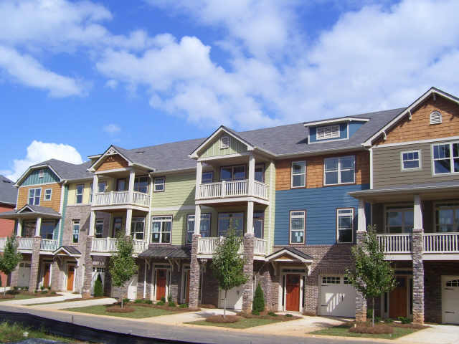__ | __ |   __ | __ |   __
 __ | 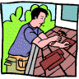  __ | 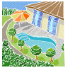  __ |  __ | 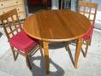__
4 Sara’s New House worksheet
② Circle the best answer.

1. Why does this person want to move?
a. Her family is coming to visit.
b. She wants a house with a swimming pool.
c. Her apartment is too small.
d. She wants more furniture.

2. What does she think about the house with the swimming pool?
a. She likes it because it is old.
b. She’s worried because it needs too many repairs.
c. She is very happy that it has a swimming pool.
d. She doesn’t think it’s big enough.

3. Which place did she buy?
a. The townhouse without a front or back yard.
b. The old house with the swimming pool.
c. The apartment she lived in.
d. The house with the “For Sale” sign.

4. How did she pay for the house?
a. She asked her family for the money.
b. She saved all of the money.
c. She decided not to buy any furniture.
d. She went to the bank to borrow money.

5. Why did she only buy a table and two chairs?
a. She didn’t need more furniture.
b. She didn’t like the furniture at the store.
c. She thought about all the food she had to buy and the money she borrowed from the bank.
d. She doesn’t have very many visitors.

4 Multi-choice Question worksheet
5. Is It Big Enough?

Activity 5

Purpose:
- to reinforce learner’s use of too, very, enough, not enough

CLB Level:
3

Time:
20 minutes

Materials:
- Too, Very, Enough, Not Enough worksheet for each learner
-My Place worksheet
for each learner

Instructions:

1. This is a grammar lesson which is a good follow-up to Sara’s New House. This is a lesson using too, very, enough, not enough. Learners are often familiar with the definition of these words and this lesson reinforces this knowledge. Too and very are adverbs and enough is an adjective.

2. Hand out Too, Very, Enough, Not Enough worksheet to the
learners. Go over definitions, taking time to give examples if
needed. Use this diagram to help explain too and very.

too cold but not
my limit
very cold but Okay

Complete ① and ② as a class, individually or in pairs.

3. ③ Read Nancy’s description of what she is looking for in a place to live. Learners read over advertisements and decide which place would be the best one for Nancy. Learners make comments using too, enough, and not enough in pairs for the other three. (Number 3 is the best one.)
(Learners may want to write sentences but it is also good practice just to make comments focusing on the grammar being taught.)

6. Have learners complete the sentences in the ④Dear Tom and Wendy worksheet using very, too, enough, not enough in their sentences. Go over to correct and have learners write their own letters using similar sentences. Learners could write the letter to you.

Answer Key:
①
1. too | 2. very | 3. very | 4. too | 5. too | 6. too
7. very | 8. too | 9. too | 10. very | 11. very
②
1. c | 2. d | 3. g | 4. e | 5. b | 6. h | 7. a | 8. f
④
1. very | 2. enough | 3. not + enough | 4. not + enough
5. too | 5. enough | 7. very | 8. very
9. enough | 10. too | 11. not + enough | 12. enough

Too, Very, Enough, Not Enough
Too - something is more than I need or want. This house is too big.
- something is less than I need or want. These bedrooms are too small.
Very - something is more than average but not too much. This house is very big. I like it.
- something is less than average but not too much. This house is very old but it’s nice.
- in negative statements, use very. This house isn’t very big.

① Complete the sentence with too or very.

1. I’m _______too______ tired to work tonight. I can’t think.
2. That’s a ________________ nice house. I love all the windows.
3. Nancy has a _______________ busy day at work tomorrow.
4. Nancy was ___________________ busy today. She didn’t have time to sit.
5. This coffee is ______________ hot to drink. I’ll wait a minute.
6. Janet couldn’t wear my jacket because it was _________________ small.
7. Terry was _______________ sick today.
8. Ben was ___________________ sick to go to work today.
9. We didn’t buy the house. The price was _________________ high. We don’t have enough money.
10. Early spring isn’t ____________________ beautiful.
11. Late spring is ________________________ beautiful.

Enough - I have as much as I need or want. I am happy. This house has enough bedrooms.

Not enough – I don’t have as much as I need or want. I’m not happy.
This house does not have enough bedrooms.

② Here are some problems people have. What do you say to them?

1. My feet really hurt. ____ a. You don’t go to the dentist often enough.
2. I don’t have any money. ____ b. You didn’t put in enough salt.
3. I failed my math test. ____ c. I don’t think your shoes are big enough.
4. I’m tired all the time. ____ d. You spend too much money.
5. This soup doesn’t taste very good. ____ e. You don’t get enough sleep.
6. I can’t sleep at night. ____ f. No thanks, I’ve had enough.
7. My teeth always hurt. ____ g. You didn’t study enough.
8. Would you like some more cake? ____ h. You drink too much coffee.

5 Too, Very, Enough , Not Enough worksheet
My Place
③ Looking for Somewhere to Live

Nancy is looking for a place to rent. She is looking for a two-bedroom unfurnished house or apartment with lots of light and a large living room. She can not pay more than $900 a month.

What would Nancy say about these places?
Use too, enough, not enough in your sentences.
1. Older two-bedroom house
Lots of beautiful oak trees
New garage
$900 plus utilities

e.g. The apartment is too big.
There are enough windows.
The apartment is not big enough.
4. Beautiful apartment $1800
3 bedrooms, 2 bathrooms
Large dining room
Indoor swimming pool
3. Bright two-bedroom apartment
Big living room
Next to fire station
$825
2. Tiny but nice
Large skylights
Very compact
$650

④Complete the sentences in this letter. Use very, too, enough or not + enough.

Dear Tom and Wendy,

Life here in Manitoba is pretty good. My apartment is nice, but the rent is (1) __very_ high. I make (2) __________________ money so I can afford it. The main problem is that the apartment is just (3) ________ big ______________. I had to sell half my furniture because I did (4) _______ have ____________________ room for everything. I can’t have people for supper because the kitchen is (5) _______________ small to eat in. But the apartment has lots of windows, so all my plants get (6)_________ sunlight.
I live (7) ______________ close to work. It only takes me a couple of minutes to walk there. It is (8) _______________ busy at work. There are not (9)______________ people to get all the work done. I often have to work overtime. I am (10) ____________ busy to make friends and I do (11) _____ get _____________________ sleep. I am always tired. I don’t even have (12) ________________ time to phone my family and friends. I hope things will slow down. Why don’t you come and see me sometime?
Love,
Mary 5 My Place worksheet
6. Applying for a Mortgage/Loan

Activity 7

Purpose:
- to become familiar with general banking terms
- to learn how to apply for a loan or mortgage

CLB Level:
3+

Time:
20 minutes

Materials:
- Vocabulary Definition cards for each pair of learners
- Client Profiles for half the class
- Banker Questions for half the class

Instructions:

1. Introduce new vocabulary to learners with Vocabulary Definition cards.
a living own owe debt
mortgage loan salary gross income
worth payments down payment net income

2. Hand out Client Profiles to half the learners. Pairs should not have the same ones. Let them look over their profiles and then the service they want from the bank in the boxes.

3. Hand out Banker Questions to the other half of the group. Bankers ask clients questions and clients, using their profiles, answer questions. Bankers then decide whether or not to give clients a mortgage/loan. Bankers tell clients why or why not.

4. Banker/client switch roles. The other half are given banker questions to ask clients.

5. Bankers discuss with clients why or why not they would give mortgages and/or loans to clients.

6. As a class discuss who got mortgages and who didn’t and what the reasons were.

For a more complex lesson see www.Bogglesworldesl.com and look for the banking lesson.

a living | a job
debt | noun – how much money you still have to pay
down payment | how much money you pay before you borrow money
gross income | how much money you get before income tax, etc. is taken off
loan | money you get for smaller purchases or projects
mortgage | money you get from the bank to buy a house
net income | how much money you get after income tax, etc. is taken off
owe | verb – how much money you still have to pay
own | when you buy something it is yours
payments | how much money is paid every two weeks or every month for something
salary | how much money you make a month or a year
worth | the value of something now (You buy a car for $10,000. In 2012, the car is valued at $2,000)

6 Definition Cards



Profession:
You are a mechanic. You earn about $3,600 a month. Last year, your gross income was $43,200.
Housing:
You rent a house for $900 a month.
Car:
You own a car. Your car is worth $32,000. You have a monthly payment of $650. You still owe $12,000.
Credit Cards:
VISA and Line of Credit. You owe $2,000 on your VISA and have a $1,000 line of credit.
Debts:
You don’t have any other debts.
Other Income:
No other income.

Profession:
You are a cook at a local restaurant. You earn about $2,400 a month. Last year you earned $30,000.
Housing:
You own your own house. Your house is worth $180,000. Your mortgage is $95,000 and your monthly payments are $750.
Car:
You own two cars. One is worth $5,000 and the other one is worth $25,000. You still owe $20,000 on the second one. Your monthly payments are $379.
Credit Cards:
You have a VISA card. You owe $500.
Debts:
You don’t have any other debts.
Other Income:
You have a renter in your basement who pays $400 a month.

Visit your bank:
1. Apply for a first mortgage.

2. Apply for a loan to buy a
$12,000 boat.

Visit your bank:
1. Apply for a $20,000 loan to
renovate your kitchen.

2. Apply for a $1,000 line of credit.

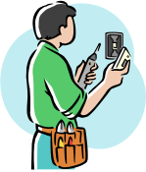

Profession:
You are an electrician. You earn about $4,800 a month. Last year, you earned $57,000.
Housing:
You own your own house. You have a mortgage of $400,000. Your monthly payments are $1,700.
Car:
You own a car. Your car is worth $35,000. Your monthly payments are $560. You still owe $8,000.
Debts:
You don’t have any other debts.
Other income:
Your spouse works as a translator. Her gross income was $18,000 last year.

Visit your bank:
1. Apply for a second mortgage. You
want a second house to rent out.

2. Apply for a loan to buy a truck.



Profession:
You are a nurse. You earn about $3,200 a month. Last year, you earned $38,400.
Housing:
You rent an apartment for $600 a month.
Car:
You own your own car. It is worth $6,000. Your monthly payments are $230. You still owe $1,500.
Credit Cards:
You have no credit cards.
Debts:
You still owe $32,000 in student loans for your education. Your monthly payments are $600 a month.
Other income:
No other income. 6 Client Cards
Visit your bank:
1. Apply for a first mortgage. You want
to buy a small house.
2. Apply for a small loan to buy
furniture.

Client Profiles

Banker: How may I help you today?
Client: I’m interested in getting a _______________________________.
Questions to Ask a Client:
1. What do you do for a living? ________________ 10. Are you renting?_____________
2. How much is your monthly salary? ____________ 11.How much is your monthly rent
3. What was your gross income last year? _________ payment?______________

4. Do you have any credit cards?_______________ 12. Do you have any other debts?___
5. How much do you owe on your credit card?_______ 13. What are your monthly payments?
_________________
6. Do you own a car?____________ 14. How much do you owe?________
7. How much is it worth?__________________ 15. Do you own a house? _________
8. Do you make monthly payments on it? ________ 16. Do you have a mortgage?_______
9. How much do you owe?_____________ 17. What are your monthly payments?
_________________
Will you give this person a mortgage? ______ Why or why not?
Will you give this person a loan? __________ Why or why not?


Banker: How may I help you today?
Client: I’m interested in getting a _______________________________.
Questions to Ask a Client:

1. What do you do for a living? ________________ 10. Are you renting?_____________
2. How much is your monthly salary? ____________ 11.How much is your monthly rent
3. What was your gross income last year? _________ payment?______________

4. Do you have any credit cards?_______________ 12. Do you have any other debts?___
5. How much do you owe on your credit card?_______ 13. What are your monthly payments?
_________________
6. Do you own a car?____________ 14. How much do you owe?________
7. How much is it worth?__________________ 15. Do you own a house? _________
8. Do you make monthly payments on it? ________ 16. Do you have a mortgage?_______
9. How much do you owe?_____________ 17. What are your monthly payments?
_________________
Will you give this person a mortgage? ______ Why or why not?
Will you give this person a loan? __________ Why or why not?

6 Banker Questions
7. Donna’s Nightmare

Activity 7

Purpose:
- to understand vocabulary words for flooding problems
- to find present perfect tense sentences

CLB Level:
3+

Time:
30 minutes

Materials:
- Donna’s Nightmare for each learner
- How Long Have You Been worksheet A and B
- On the Board Activity

Instructions:
1. Introduce the lesson by saying, “You have bought your house, now the problems begin.” Brainstorm housing problems that learners have now or have had in the past.

2. Hand out Donna’s Nightmare A or B to the learners. Have the learners circle the vocabulary words in the letter. Go through the definitions together. Have the learners go through the vocabulary words orally.

3. Read through Donna’s Nightmare together once. Have the
learners read the letter in pairs or as a class. Write the
following Discussion Questions on the board and have learners
discuss them in pairs or as a class:
a. Who lives in the house?
b. What are 4 or 5 things that made this house a nightmare?
c. What did the plumbers tell Donna?
d. What advice would you give Donna?

4. This is a good letter to use for teaching the present perfect tense with the use of since and for. There are several examples in the text.
a. Work through the first page of How Long Have You ...
grammar worksheets with the learners before finding the
examples in the text.
b. Find the examples in the Donna’s Nightmare text.
c. Work through the rest of the grammar worksheet.
d. Draw the chart of the On the Board Activity on the board and have learners use this as a guideline to ask questions. Let them know they can make their own statements. Divide the class into pairs and demonstrate with this example. One learner makes a statement such as, “I am married.” The other learner asks, “How long have you been married?”
Optional activity: All learners write a sentence following the above format. (I have studied English for 8 months.) Learner 1 tells Learner 2 what he/she has written. Learner 2 tells Learner 1 what he/she has written. Learner 1 then finds another learner and relates the new information to another learner. “Bob has studied English for 8 months.” Learners keep exchanging information. After 5-10 minutes ask learners what they remember about whom.

Donna’s Nightmare A Answer Key:
1 | 2 | 3 | 4 | 5 | 6 | 7 | 8 | 9 | 10 | 11 | 12
i | c | h | a | f | k | e | l | j | b | d | g
Match the following words or phrases with their definitions.

1. fed up ____ a. the bad water comes back into the house
2. contractor ____ b. where the water goes down
3. nightmare ____ c. person who finds workers to build a house
4. sewer backed up ____ d. air goes out of the house
5. sump pump ____ e. water on the floor
6. toilets didn’t flush ____ f. pumps water from underneath the house to the outside
7. basement flooded ____ g. get money legally for something done wrong to you
8. fired ____ h. bad dream
9. illegal ____ i. had enough
10. drain ____ j. not legal
11. vented ____ k. water didn’t go down the toilet
12. sue ____ l. lose a job
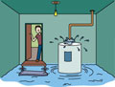

Read the following letter. Circle the above words or phrases.

Donna’s Nightmare

Dear Mr. Fix It:
I’m a single mom who bought a newer home three years ago. I was very excited about having my own home but it has been a nightmare! The first six months we lived there, the sewer backed up, the sump pump quit, the toilets didn’t flush, and the basement flooded. We have been in the house for three years and it has flooded five times!
The contractor told me that he fired the plumber who did the work. I have been frustrated with them for three years now. I hired three different plumbers. They all said that the plumbing is illegal in the house. They said that the plumbing is not vented!
My daughter and I have been sick since we moved here. We always feel tired and we have had flu-like symptoms for a year. I am worried about my daughter. We have phoned the contractor for months to come and fix this problem but he hasn’t come yet. I am fed up with him and I’m thinking about suing him.
Sincerely,

Donna Winters
7 Donna’s Nightmare
How Long Have You ...?
(Present Perfect: For/Since)

● The Present Perfect is used for something in the past that is connected to the present.
● The Present Perfect always uses have plus the past participle verb or has plus the past participle verb.

1. Look at the diagram below. for
6 months

live in Steinbach now

● Read the diagram above like this: I have lived in Steinbach for six months.
We use for when we talk about a length of time.

2. Look at the diagram below. since
●
July now

● Read the diagram above like this: I have lived in Steinbach since July.
We use since when we talk about a starting time.

3. Group the following words. Do we use ‘for’ or ‘since’ in front of these
groups of words?

● two weeks | ● last year | ● I was a child | ● 2 p.m. | ● three hours
● 12 years | ● 2005 | ● yesterday | ● 8:15 | ● months
● we moved here | ● 5 years | ● a long time | ● 10 minutes | ● years

FOR SINCE
_____________________
_____________________
_____________________
_____________________
_____________________
_____________________
_____________________
_____________________

_____________________
_____________________
_____________________
_____________________
_____________________
_____________________
_____________________
_____________________

7 How Long Have You Been worksheet A

4. Look at some common verbs used with the Present Perfect.
Base form Past tense Past participle

be was, were been
go went gone
have had had
know knew known
live lived lived
own owned owned
speak spoke spoken
work worked worked

5. Complete the sentences using for or since.

1. We have been in Canada _____________ two years.
2. Our neighbours have had the same car _____________ many years.
3. I have lived in the same house ________________ I was born.
4. I have owned this house ________________ 2001.

6. Make sentences using for or since.

1. I have lived in Canada since 2002.
I / live / in Canada / since
2. _______________________________________________________
I / speak / English / for
3. _______________________________________________________
I / have / my driver’s license / for
4. _______________________________________________________
She / be / married / for
5. _______________________________________________________
He / work / for Diamond Construction / since
6. _______________________________________________________
I / not buy/ a car / for
7. _______________________________________________________
My daughter / have / a cold / for
8. _______________________________________________________
We / own / our house / since

7 How Long Have You Been worksheet B
Answer Key: 5. b. -- Donna’s Nightmare

Dear Mr. Fix It:
I’m a single mom who bought a newer home three years ago. I was very excited about having my own home but it has been a nightmare (for three years)! The first six months we lived there, the sewer backed up, the sump pump quit, the toilets didn’t flush, and the basement flooded. We have been in the house for three years and it has flooded five times!
The contractor told me that he fired the plumber who did the work. I have been frustrated with them for three years now. I hired three different plumbers. They all said that the plumbing is illegal in the house. They said that the plumbing is not vented!
My daughter and I have been sick since we moved here. We always feel tired and we have had flu-like symptoms for a year. I am worried about my daughter. We have phoned the contractor for months to come and fix this problem but he hasn’t come yet. I am fed up with him and I’m thinking about suing him.
Sincerely, Donna Winters

On the Board Activity
Use this activity for 5. d. – Donna’s Nightmare

Example: Partner A: I live in Steinbach.
Partner B: How long have you lived in Steinbach?
Partner A: for six months or since 2006.

Partner A | Partner B
I live in _____________
I work at_____________
I study English.
I have a mini-van.
I have ______________

7 Answer Key and On the Board Activity
8. A House Nightmare

Activity 8

Purpose:
- to identify plumbing problems in a house
- to communicate plumbing problems

CLB Level:
2/3

Time:
15 minutes

Materials:
- Plumbing Problems worksheet
- A House Nightmare worksheet
- Calling the Service Technician worksheet (each page makes 2 copies)
-Classifieds or Phone Book (optional)

Instructions:

1. This is a continuation of Donna’s Nightmare discussing plumbing problems more in detail. Hand out Plumbing Problems worksheet to learners and go through the vocabulary together.
Answer Key:
1. leaky, dripping 2. blocked, clogged, plugged 3. rusty
4. broken, worn out 5. noisy 6. low
7. cracked 8. slow 9. running 10. broken

2. Hand out A House Nightmare worksheet to learners. Write the vocabulary on the board and have learners label these things in the house.
Vocabulary: roof, attic, ceiling, shower, toilet, sink, refrigerator, pipes, washer/dryer, water heater, cracked pipe, garden hose, furnace

3. Discuss other problems with a house and name the service person that you would need to call.

4. Divide class into pairs. Hand out Calling the Service
Technician worksheet. Learner 1 calls the service technician and states a problem. The service technician then points to the problem and writes the number beside it. Learner 2 repeats the scenario with his/her problems. Learners then write down who they need to call and find phone numbers in the classified section of a newspaper or the yellow pages of a phone book. (The latter part may be given as a homework assignment.)
Answer Key: Customer 1
1. plumber 2. appliance repair technician 3. plumber
4. plumber 5. roofer or roofing contractor 6. plumber
7. plumber (in house problem) public works employee (city problem)
Answer Key: Customer 2
1. appliance repair technician 2. plumber 3. plumber 4. plumber
5. plumber 6. plumber 7. roofer or roofing contractor

Tip: Some examples of what may not be included in a typical policy are:
1. Smoke damage may be covered if from a malfunctioning heating device, but not from a fireplace.
2. Vandalism may be covered if the building is usually occupied.
3. Wind and hail damage to a building exterior may be covered, but not an antennae or satellite dish mounted on the outside of the building.
4. Manitoba residents may want to have "sewer backup" coverage;
5. Property or materials/inventory relating to your home-based or commercial business, or tools and equipment may not be covered, or covered to a limited extent.
6. Contrary to popular belief, many "Acts of God" are covered. Most insurance
policies will cover lighting, hail damage, or a tornado striking your home.
Garriok Insurance
Plumbing Problems

Look at each picture below. Choose a word or phrase that best describes the problem you see in each picture. Write it on the line above the picture.
blocked broken broken clogged cracked dripping
leaky low noisy plugged running rusty
slow worn out

1. a ______faucet  a______faucet  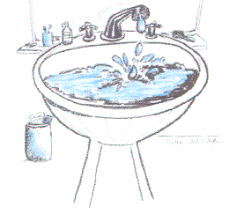 | 2. a _______drain  a _______drain  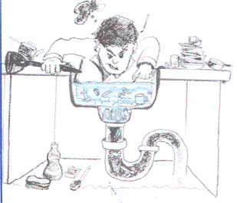  a _______drain |  | 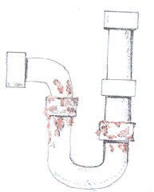  3. a _______pipe |  | 4. a _______part  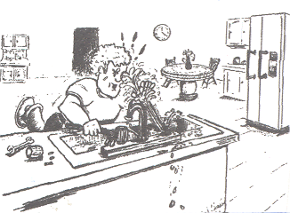  a ___ ____ part
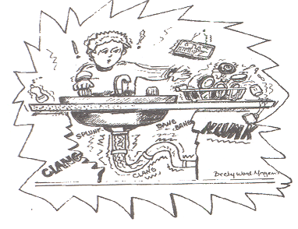  5. __________ pipes |  | 6. ______ water pressure  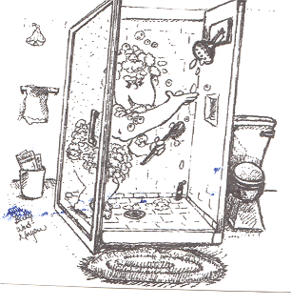 |  | 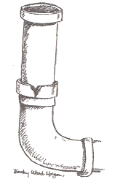  7. a __________ pipe
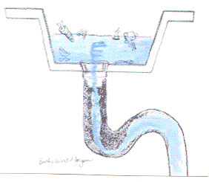  8. a _________ drain |  | 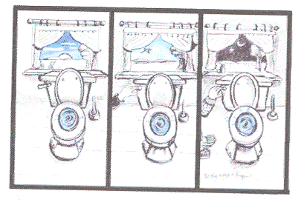  9. a _________ toilet |  | 10. no hot water  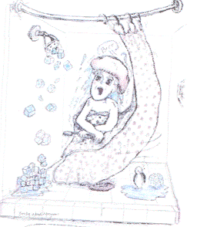  a ________water heater

8 Plumbing Problems worksheet






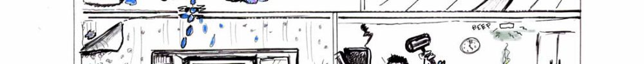





Plumbing House Nightmare
Help! Call the Plumber Virginia Adult Learning Resource Center Lesson One Facilitator Materials
8 A House Nightmare
Calling the Service Technician

Customer 1: Hello, this is __________________. I need someone to come out today. We’re having a lot of problems.
Service Technician: What kinds of problems?

1. The bathroom sink on the second floor is clogged.
2. The washer in the basement is leaking. The water is running under the dryer.
3. The toilet doesn’t stop running.
4. The pipe under the kitchen sink is cracked.
5. Water is dripping from the living room ceiling.
6. There is no hot water.
7. The sewer is backing up in the basement.



Calling the Service Technician

Customer 2: Hello, this is __________________. I need someone to come out today. We’re having a lot of problems.
Service Technician: What kinds of problems?

1. There is water under the refrigerator. I don’t know why it’s leaking.
2. The faucet in the kitchen is leaking.
3. The pipes from the hot water heater are rusty.
4. The drain in the kitchen sink is plugged.
5. There is very little water coming from the shower. The water pressure is very low.
6. The toilet is plugged. It’s overflowing.
7. The roof is leaking.

8 Calling the Service Technician worksheet

